A Modified Method for Increasing Radiochemical Purity of I-125 for Radiopharmaceutical
Atom Indonesia

A R T I C L E I N F O a B S T R A C T

AIJ use only:  Received date  Revised date  Accepted date  Keywords:  Iodine-125 radioisotope  Impurities  radiochemical purity  radiopharmaceuticals  the Jones reductor |  | Iodine-125 (¹²⁵I) is one of the radioisotopes widely used in radiopharmaceuticals for diagnosis and therapy of various cancers. Recent reports indicate that there has been shortages in the world supply of this radioiodine isotope. One of the absolute requirements to meet good radiopharmaceuticals is radiochemical purity, which is generally above 95% with efficiency over 90%. The previous investigation shows that the radiochemical purity is low and does not meet the radiochemical requirement. In this work, we aim at improving the previous method by modifying the Jones reductor-based method. The modified method includes a variation of Zn particle sizes, Zn particle compaction, and the reduction process was performed in a closed process flow. The Jones reductor converted impurities into products, in this case, iodate (IO₃⁻) and periodate (IO₄⁻) impurities were converted into iodide (I⁻), so that ¹²⁵I product with radiochemical purity met the requirements and yielded high efficiency. In this investigation, the ¹²⁵I previous product was, for the first time, improved with the radiochemical impurity of 99.24% and an efficiency of 97.98%.  © 2021 Atom Indonesia. All rights reserved

Introduction∗

There has been an increasing demand for ¹²⁵I radioisotope on the world market for research, diagnosis, and therapy [1-3]. However, there has been limited availability of ¹²⁵I products worldwide. According to the Distributed Objects and Applications (DOA) symposium in 2004, the only ¹²⁵I producer was McClellan/UC Davis, and the ¹²⁵I product was not sufficient for domestic markets in the United States. In the US alone, there were around 36,000 procedures which required radioisotopes, including ¹²⁵I [3]. In Indonesia, ¹²⁵I has been widely used in the field of health, agriculture, and energy [2]. In the medical field, ¹²⁵I is employed as a tracer in Radioimmunoassay (RIA) and Immunoradiometric Assay (IRMA) such as PSA, CA125, CA 153 kits for early detection of various cancer in-vitro [4]. Iodine-125 is also often used to treat various types of cancer such as prostate cancer through the brachytherapy method or by being bound as a radiopharmaceutical compound [5-9].
The wide use of ¹²⁵I as a radioisotope marker in the field of radiopharmaceuticals both for diagnostic and therapeutic purposes related to the chemical nature and diversity of available decay schemes making it possible to be used for a variety of medical applications [10-11]. A radiopharmaceutical is a radioactive-labeled compound that meets the requirements for pharmaceutical products, used for diagnosis or treatment of various diseases [12]. Iodine-125 as a radioisotope marker generally has several advantages, including easy binding to organic molecules especially those containing tyrosyl groups such as proteins or smaller molecules such as thyroxine in peptides, and the resultant marking obtained can have high purity and specific activity [2]. Besides, ¹²⁵I is a gamma-ray emitter with low-energy (35 keV) that can be detected with most gamma counters with high efficiency, and its half-life is relatively long, which is 60 days [13]. Furthermore, ¹²⁵I is an Auger electron emitter with energies between 10 eV and 34 keV which, when reaching the nucleus of infected cells for the treatment of proliferative tumors and apoptotic effects, do not damage normal cells [14-17].
One of the most important parameters in the use of radioisotope for radiopharmaceutical requirements is related to radiochemical purity. Therefore, radiochemical purity has always been the basis for determining the quality of radiopharmaceuticals [12, 18]. Radiochemical purity is the ratio between radioactivity in the desired chemical form and total radioactivity [19,20]. Radiochemical purity that does not meet the requirements (<95%) will cause the compound to be distributed to other organs, causing undesired radiation exposure and making image quality poor [2, 12, 21].
The former Indonesian National Nuclear Energy Agency (BATAN) has been able to produce large quantities of ¹²⁵I radioisotope, however, in recent years the resulting ¹²⁵I quality has decreased due to the low purity of its radiochemistry so that its use is limited to certain fields. As a result, the ¹²⁵I cannot be used optimally [2]. Various attempts have been made to improve the quality of the ¹²⁵I but have not yet achieved the results expected for use in the field of radiopharmaceuticals, either for research, diagnosis, and therapy purposes [1, 2]. Unfortunately, there have been no published references that discuss such a problem. A previous study conducted by Maiyesni, et al. [1], used Jones reductor, a solid amalgam in the form of mercury/zinc amalgam, to increase the radiochemical purity of ¹²⁵I. The Jones reductor was entered into the chromatography column, then ¹²⁵I in the form of a solution of sodium iodide (Na¹²⁵I) was passed into the column several times. The result indicated that although the ¹²⁵I solution was found to have high radiochemical purity, the purification efficiency was still low so that many products were lost during the reduction process. With this method, it is also feared that mercury bound to zinc might be eluted along with ¹²⁵I at an undesired amount due to being eluted many times in the Jones reductor column. If this happens it is certainly very dangerous for patients since mercury is among the most dangerous heavy metals [22, 23].
Since the price of Na¹²⁵I radioisotope is relatively expensive and the manufacturing process is complex, it is very important to find a more effective reduction method to increase the radiochemical purity of Na¹²⁵I to the required limits but with the highest efficiency, up to 90%.
This study aims to improve the purity of radiochemistry with high efficiency by modifying the purification process flow. The process of reduction (purification) is done by placing a closed system that can convert impurities into products, in this case, iodate (IO³⁻) and periodate (IO⁴⁻) are converted into iodide (I-) impurities. In this research, the purification of ¹²⁵I solution using Jones reductor was done by modifying the previous method as discussed in ref. [1]. The system developed in this modification consists of Jones reductor, which is a zinc amalgam (ZnHg) in the form of a solid which is compressed in a chromatographic column in a closed system. In this method, a tap to drain nitrogen is placed between the Jones reductant chromatography column and the holding container. The flow of nitrogen gas during the reduction process aims to expel oxygen gas from the storage container which can cause re-oxidation of sodium iodide-125 solution (Na¹²⁵I). By modifying the flow of this process, it is expected that a ¹²⁵I solution will not only have high radiochemical purity but also high purification efficiency.
Several analytical methods can be used to detect and determine the purity of radiochemistry in radiopharmaceutical compounds. Commonly used methods are precipitation, paper chromatography, thin-film, and gel chromatography, gel and paper electrophoresis, cation exchange, solvent extraction, HPLC, and distillation [24-27].
In this study, the determination of the radiochemical purity of paper chromatography was chosen because it was considered relatively more suitable for determining different components in a ¹²⁵I bulk solution and was also simple. In this technique, each component of the sample is characterized by the value of the specific retention factor (Rf) used for species identification. Rf is the ratio of the distance traveled to the medium (stationary phase) by the radiochemical species given to the distance traveled by the front of the solvent (mobile phase) [1,2,27].

METHODOLOGY

The equipment used in this experiment includes a chromatography column (locally manufactured), mini vacuum pump, dose calibrator (atom-lab), Gamma counter (Nucleus model 600B), automatic counter (Bioscan AR200) ​​, and various glassware. The materials used include Zink Coarse Powder Gr for filling reductants (Merck), Mercury (II) Chloride (Merck), methanol pa (Merck), Whatman paper No. 1, NaOH (Merck), HCl (Merck), and demineralized H₂O.
The previous method as described in ref [1] was also repeated in order to compare the results with the modified method. In the modified method, Zn powder was mashed and sieved to obtain a certain size that is relatively uniform. Then 2% HgCl₂ solution was added, allowed to mix for 10 minutes to form Zn-Hg powder (Zn amalgam = Jones reducing agent). The reducing agent formed was separated from the remaining HgCl2 solution and decanted with sufficient demineralized H₂O to remove the remaining Hg which is not bound to the Zn metal. Furthermore, to activate the Jones reducing agent added 10 ml of 5% HCl stirred for ± 5 minutes. The Jones reducing agent was separated from the HCl solution and entered into the chromatographic column. The column containing the Jones reducing agent was compacted by a vacuum pump. Furthermore, the Jones reducing agent was washed with demineralized H₂O to neutral pH while remaining vacuum. Furthermore, it flowed with 0.01 N NaOH until the pH reached 10-11. After the reductant's pH was at base pH (10-11), a bulk Na¹²⁵I solution was put into Jones's column reductor. After incubating for nearly 10 minutes, then the column was eluted with 0.01 N NaOH solution and accommodated in a closed container equipped with a nitrogen drainage valve. Nitrogen faucets remained open during the process of storing liquids to expel available oxygen during the reduction process. The Jones reductor is schematically shown in Figure 1.

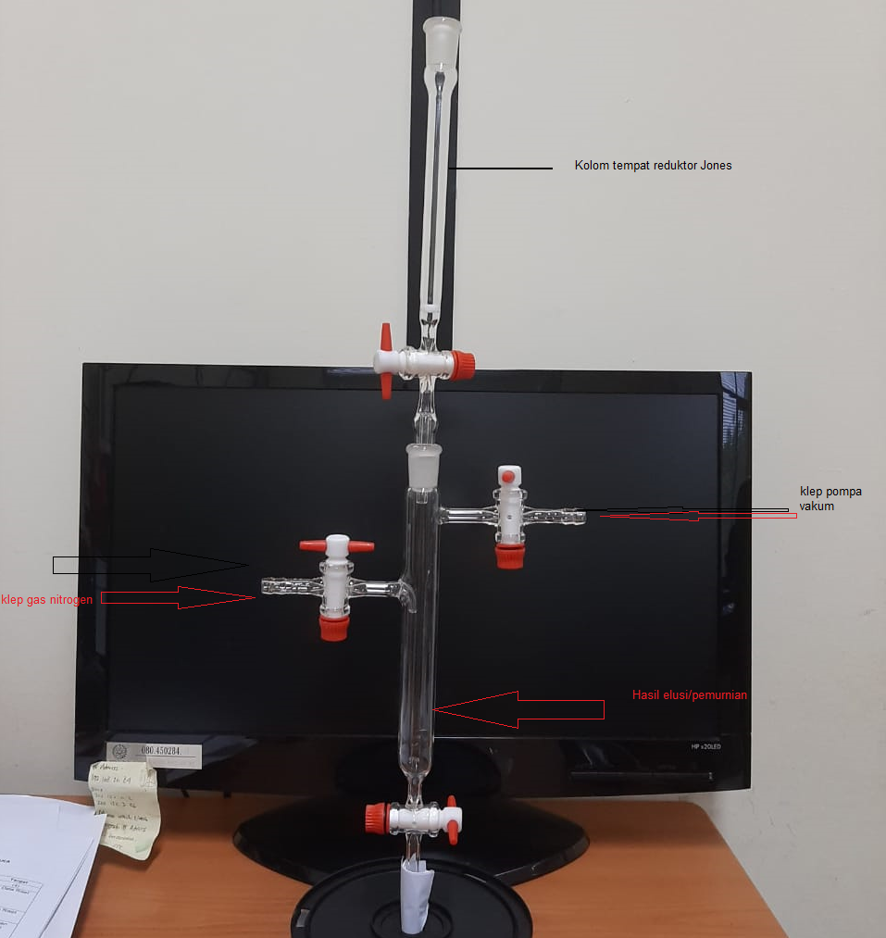
Jones reductor column
Nitrogen gas inlet
Vacuum pump valve
Elution product
Jones reductor column
Nitrogen gas inlet
Vacuum pump valve
Elution product
Fig. 1 Schematic diagram of the modified Jones reductor-based method
Jones reductor column
Nitrogen gas inlet
Vacuum pump valve
Elution product

The radiochemical purity was carried out using the paper chromatography method. As the stationary phase, Whatman paper number 1, whereas MeOH: H₂O (750: 30) was used as the mobile phase. Then carefully pour the sample solution so that a small dot was formed on Whatman paper at a distance of 2 cm from the bottom of the paper (zero points) and dried. After drying, it was eluted up to a migration distance of 35 cm, removed, and dried by aerating. Following drying the paper was cut into 1 cm size, then it was chopped one by one using a beta counter.

results and discussion

The results of each radiochemical improvement process using the method described in ref. [1] can be seen in Figure 2, which shows the bulk Na¹²⁵I solution before the reduction process with radiochemical purity is still very low (50.53%). Therefore, further reduction processes must be carried out to obtain an acceptable level of purity.
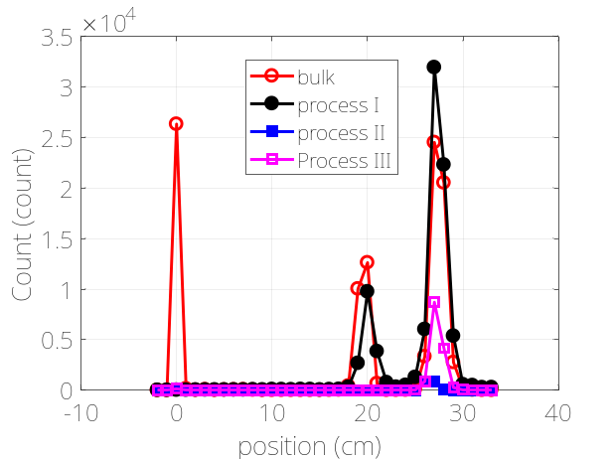

Fig. 2 Radiochemical purity of bulk Na¹²⁵I Solution by Paper Chromatography with ethanol mobile phase: H₂O = 75:25

After the reduction by passing the Na¹²⁵I bulk solution into the chromatographic column containing the Jones reductor in the first elution, there was an increase in radiochemical purity to 76.69%. Because radiochemical purity is still <95% as a requirement for a radiopharmaceutical, it is necessary to do a second reduction. In the second reduction, the radiochemical purity was 90.90%. Because of the reduction for the second time of the radiochemical purity of the Na¹²⁵I solution, it has not yet reached the specified standard, so the reduction was carried out for the third stage. The elution of Na¹²⁵I solution in the third stage resulted in a 98.96% purity. It was seen that after the reduction of the third stage only the radiochemical purity of Na¹²⁵I solution was obtained, which meets the radiopharmaceutical purity standard (>95%).
It can be seen that 3 times reduction is required to obtain purity per the requirements, namely by passing into the chromatography column 3 times. This has the consequence of low production efficiency. In this method, the elution efficiency is only 74.72% with a deviation standard of 0.61. The low efficiency of the product may be because at each stage of the reduction process a product loss occurs either left behind in different columns, pipettes, or storage containers.
Due to the high price and the difficulty of the ¹²⁵I production process, a more effective and simple method is sought so that product loss during the process can be minimized. Therefore, it is necessary to modify the method to improve the performance of Jones reductor and simplify the process. With this modification, it is expected that the reduction process does not need to be repeated, but only once. In this research, optimization of Zn size is carried out by reducing and uniformity, using a vacuum pump to condense and storing closed products and nitrogen flow to expel oxygen which can cause oxidation again. The modification involves reducing and uniforming Zn grain size, which aims to expand the contact surface. Compacting the arrangement of Jones reductant particles with a vacuum pump to multiply the number of particles in the same column volume also increases the surface area of ​​the reductant and the reaction surface. Thereby increasing the chance of iodine solution to interact with the reducing agent. Reservoirs are in a closed system and flowed liquid nitrogen aims to expel and prevent the entry of oxygen which can cause oxidation again. The results of the reduction process by modifying this method can be seen in Figure 3.

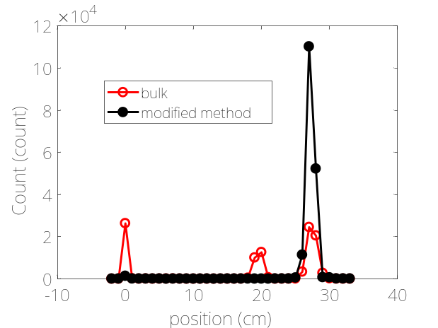

Fig. 3 Radiochemical Purity of Na¹²⁵I solution obtained from the modified method of Paper Chromatography

As can be seen in Figure 3, after a modification of the reduction process is carried out, with just one reduction, the radiochemical purity of the Na¹²⁵I product solution 99.24%, which meets the requirements, whereas the efficiency is 97.98% (> 90% as required) and the standard deviation is 1.73%. By doing some modifications to the reduction method it has been proven that it can improve the radiochemical purity of Na¹²⁵I bulk solution to meet the requirements for use as a labeled solution in a radiopharmaceutical for both diagnostic and therapeutic purposes of various types of cancer with high efficiency. Besides, this method also makes the process flow simpler so that the processing time is quicker and is very helpful to reduce radiation exposure for radiation workers during the process. Note that the higher than 99% radiochemical purity of I-125 achieved in this experiment is in good agreement with previously published work [28-29].

conclusion
Efforts to modify the reduction process of Na¹²⁵I bulk solution have been performed to increase the level of radiochemical purity and efficiency to an acceptable level for radiopharmaceutical requirements both for diagnostic and therapeutic purposes for various types of cancer. Furthermore, this modification is also very beneficial because it can increase the number of Na¹²⁵I products that meet the requirements to 99.24% radiochemical purity, whereas in the previous process it only reached 98.96%. In addition, for the first time, with such a high radiochemical purity, the elution efficiency is also increased from 74.72% to 97.98%. As well, a quicker processing time involving radioactive material is important since it can reduce the risk of radiation exposure to radiation workers, and this was also achieved in this modified method. In conclusion, the modified method indicates that it results in three improvements, i.e. higher radiochemical purity (99.24%), higher efficiency (97.89%) and quicker process.

ACKNOWLEDGMENT
This research is fully supported by the Indonesian National Nuclear energy Agency research grant, DIPA 2018. Discussion with the Radioisotope Technology Division of BATAN staff is also greatly acknowledged.

AUTHOR CONTRIBUTION
Maiyesni and I. Kambali equally contribute as the main contributors whereas all other authors read and approved the final version of the paper.

references
- Maiyesni, Mujinah, Witarti, D. Kurniasih, et al., Jurnal Kimia Valensi 3 (2013) 65.
- Maiyesni, Mujinah, Witarti, D. Kurniasih, et al., Indonesian Journal of Nuclear Science and Technology 17 (2016) 59.
- A. Kar. Novel ¹²⁵ I Production and Recovery System. Texas: Texas A&M University (2010).
- A. Tshiband, L. Mputu, R. Tozin, Ingala, et al., J. Biomed. Eng. Med. Devices 01 (2016) 1.
- Q. Li, Y. Tian, D. Yang, Y. Liang, et al., Technol. Cancer Res. Treat. 18 (2019): 1.
- R. Li, Z. Ying, Y. Yuan, Q. Lin, et al., Brachytherapy 18 (2019) 87.
- J. Zhou, L. Hao, Z. Shi, S. Ning, et al., Oncol. Lett. 14 (2017) 6403.
- A. Wals, J. Nanoparticle Res. 19 (2017) 152.
- M. Sadeghi, M. Enferadi, A. Shirazi, J. Cancer Res. Ther. 6 (2010): 239.
- M. Mourad, A. Amin, H. Elsabagh, G. Mohamed, et al., Arab J. Nucl. Sci. Appl. 51 (2018) 107.
- I. T. Al-Alawi, R. S. Mohammed, Int. Lett. Chem. Phys. Astron. 63 (2016) 90.
- C. Maioli, G. Lucignani, A. Strinchini, L. Tagliabue, et al., Acta Biomed. 88 (2017) 49.
- P. Zhao, M. Q. Zhang, Y. L. Zhang, Y. C. Guo, et al., J. B.U.ON. 22 (2017) 265.
- O. L. Da Costa, D. C. B. Souza, A. Feher, M. E. Rostelato, Brazilian Demand For Iodine - 125 Seeds In Cancer Treatment After A Decade Of Medical Procedure, Proceedings of the International Nuclear Atlantic Conference (INAC) (2017) 1.
- C. J. Shen, I. I. Minn, R. F. Hobbs, Y. Chen, et al., Theranostics 10 (2020) 2888.
- A. A. Amin, N. S. Farrag, A. AbdEl-Bary, Br. J. Pharm. Res. 4 (2014) 1873.
- A. P. Kiess, I. I. Minn, Y. Chen, R.Hobbs, et al., J. Nucl. Med. 56 (2015) 1401.
- L. P. Vincenti, A. Samuel, F. Zarb, Int. J. Radiol. Imaging Technol. 2 (2016) 2.
- E. De Bois, R. M. S. De Zanger, H. S. Chan, M. Konijnenberg, et al., EJNMMI Radiopharm. Chem. 4 (2019) 1.
- H. H. Coenen, A. D. Gee, M. Adam, G. Antoni, et al., J. Labelled Comp. Radiopharm. 61 (2018) 402.
- C. R. Bush, J. E. Coughlin, T. J. Herold, J. C. Hung, Nucl. Med. Biol. 24 (1997) 479.
- M. Vahabzadeh, M. Balali-Mood, Int. J. Occup. Environ. Med. 7 (2016) 116.
- Y. Byeong-Jin, K. Byoung-Gwon, J. Man-Joong, K. Se-Yeong, et al., Ann. Occup. Environ. Med. 28 (2016) 1.
- H. Sadeghpour, M. Alavi, M. Shahedi, S. M. Entezarmahdi, et al., Trends Radiopharm. Sci. 1 (2015) 15.
- M. R. Ghahramani, A. A. Garibov, T. N. Agayev, J. Chromatogr. Sep. Tech. 06 (2014) 1.
- R. De Zanger, E. De Blois, W. Breeman, J. Nucl. Med. 58 (2017) 258.
- H. Ullah, I. Ahmad, M. Khattak, S. Shah, et al., Iran. J. Nucl. Med. 27 (2019) 19.
- S. Mushtaq, Y. R. Nam, J. A. Kang, D. S. Choi, et al., ACS Omega 3 (2018) 6903.
- J. I. M. van Uhm, G. W. M. Visser, M. J. van der Schans, A. A. Geldof, EJNMMI Research 5 (2015) 5.

∗ Corresponding author. E-mail address: maiy001@brin.go.id DOI: provided by AIJ

