Dosimetric Comparison of Focused and Collimated Very High Energy Electron (VHEE) Beams in the Male Pelvic Region Using Geant4/TOPAS
Atom Indonesia

El Mehdi Essaidi^{1*}, Mustapha Krim¹, Othmane Kaanouch¹, Meriem Tantaoui², Mohammed Reda Mesradi¹, Abdessamad Didi¹Driss Benchekroun³
¹Hassan First University of Settat, High Institute of Health Sciences, Laboratory of Sciences and Health Technologies, BP 555, 26000, Settat, Morocco
²Subatomic Research and Applications Team, Laboratory of the Physics of Condensed Matter (LPMC-ERSA), Faculty of Sciences Ben M’Sik, Hassan II University, BP 7955, Casablanca, Morocco
³Laboratory of High Energy Physics and Condensed Matter, Department of Physics,Faculty of Sciences Aïn Chock, Hassan II University, Casablanca, Morocco

A R T I C L E I N F O a B S T R A C T

AIJ use only:  Received date  Revised date  Accepted date  Keywords:  Very High Energy Electrons (VHEE) Focused VHEE beams  Collimated VHEE beams GEANT4/TOPAS Monte Carlo simulations Quadrupole magnets Radiological Protection. |  | The CLEAR (CERN Linear Electron Accelerator for Research) facility has made notable strides in advancing high-energy electron radiotherapy, particularly for the treatment of deep-seated tumors. Despite these advancements, challenges remain in achieving precise and accessible treatment delivery while minimizing damage to healthy surrounding tissues. Very High Energy Electrons (VHEE) demonstrate significant potential due to their deep penetration capabilities; however, their nearly uniform dose distribution raises concerns about impacting healthy tissues. A key innovation in this field is the utilization of focused VHEE beams, which deliver a concentrated dose to a small, defined area at a high dose rate, potentially enhancing treatment precision. This study evaluates the dosimetric characteristics of focused VHEE beams compared to collimated ones, employing GEANT4/TOPAS Monte Carlo simulations. A beamline was designed with two quadrupole magnet triplets to focus VHEE beams on a water phantom, simulating clinical conditions. The findings show that focused VHEE beams increased the dose to the prostate by 5.24% while significantly reducing the dose to adjacent organs at risk: 16.93% to the bladder, 50.81% to the rectum, and 68.75% to the femoral heads. These reductions highlight the dosimetric advantage of focused VHEE beams in sparing non-targeted tissues. While these results underscore the potential benefits of focused VHEE beams for deep-seated tumor treatment, additional research, including clinical validation and patient-specific modeling, is essential to fully evaluate their clinical utility. This study lays the groundwork for optimizing VHEE beam applications in cancer therapy by demonstrating improved dose delivery accuracy and reduced risk to adjacent organs.  © 2021 Atom Indonesia. All rights reserved

Introduction∗
The commissioning of the CERN Linear Electron Accelerator for Research (CLEAR) marks a significant milestone in medical physics and accelerator technology, building on the foundation of the Advanced Proton Driven Plasma Wakefield Acceleration Experiment (AWAKE). Developed from the CLIC Test Facility 3 (CTF3), CLEAR became operational in 2017 with the goal of advancing research in accelerator development, high-gradient acceleration, beam instrumentation, and medical applications such as FLASH radiotherapy and dosimetry.
Very High Energy Electron (VHEE) beams, in the energy range of 100 to 250 MeV, were first proposed for radiotherapy by DesRosiers et al. in 2000 due to their potential for treating deep-seated tumors [1]. Later studies, such as those by Lagzda et al., demonstrated their effectiveness in addressing tumors located in highly heterogeneous and mobile tissues [2]. VHEE radiotherapy offers several advantages over traditional external beam radiotherapy, including deeper dose penetration, better dose conformity, higher dose rates, and the ability for magnetic beam steering, as highlighted by Ronga et al. and Schüler et al. [3][4]. Additionally, the development of C-band radio-frequency (RF) accelerators and Laser Wake-Field Accelerators (LWFA) is expected to increase the availability of VHEE sources, as noted by Poppinga et al. and Fuchs et al. [5][6].
Despite these advantages, VHEE beams pose challenges, particularly their quasi-uniform dose distribution along the beam path, which may result in unnecessary exposure to healthy tissues, as discussed by DesRosiers [7]. Addressing these challenges requires innovative solutions to enhance dose delivery while reducing collateral effects. The introduction of focused VHEE beams offers a promising solution by concentrating the dose within a small, well-defined region at a high dose rate, as shown by Bazalova-Carter et al. [8]. Previous work by Whitmore et al. and Kokurewicz et al. demonstrated that the use of quadrupole magnets to focus VHEE beams improves dose distribution by reducing entrance dose and enhancing precision in targeting within water phantoms [9][10].
Several studies have expanded on the clinical applications and advantages of VHEE beams in radiotherapy. Foundational research by DesRosiers et al. (2000) emphasized the potential of 150–250 MeV electron beams for cancer treatment [1], while Hogstrom and Almond (2006) provided a comprehensive review of the principles of electron beam therapy physics [11]. Monte Carlo simulations by Glinec et al. (2006) illustrated the feasibility of using laser-plasma accelerators for radiotherapy [12], and Lundh et al. (2012) validated the accuracy of VHEE beam dose distribution through comparisons between experimental and calculated data [13]. Further work by DesRosiers et al. (2008) demonstrated the superior performance of VHEE beams for deep-seated lung tumors compared to conventional megavoltage photon beams [14]. Schüler et al. (2017) showed that VHEE beams offer better dose conformity and reduce exposure to healthy tissues compared to VMAT and PPBS techniques [4]. In several fields, a lot of work has been done using Monte Carlo simulations to explain certain ideas and achieve goals aimed at improving results [15-17].
Other research has focused on the use of laser-plasma-generated VHEE beams for prostate cancer treatment, as studied by DesRosiers et al. (2008) [18], and on the development of laser-accelerated VHEE beams for treatment planning, as explored by Fuchs et al. (2009) [6]. Bazalova-Carter et al. (2015) compared VHEE and VMAT plans, demonstrating the superior dose distribution achieved with VHEE [8]. Labate et al. (2020) investigated multi-field and intensity-modulated strategies for laser-driven VHEE therapy, emphasizing their potential for optimizing treatment [19]. Kokurewicz et al. (2019) introduced focused VHEE beams as a novel modality, demonstrating their ability to achieve precise dose delivery with high accuracy [20].

This study presents the design and implementation of a beamline using two quadrupole magnet triplets to focus VHEE beams on a water phantom. It compares the dose deposition characteristics of focused versus collimated VHEE beams, highlighting the superior performance of focused beams in targeting deep-seated tumors. The results demonstrate that focused VHEE beams significantly enhance targeting precision while reducing doses to nearby organs, offering improved safety for patients and protection for healthcare personnel. A dosimetric comparison applied to the male pelvic region, modeled using a mathematical phantom with realistic dimensions in GEANT4/TOPAS Monte Carlo simulations, further underscores the clinical potential of focused VHEE beams in minimizing doses to organs at risk.
METHODS AND MATERIALS
This study investigates the dose deposition characteristics of focused Very High Energy Electron (VHEE) beams in comparison to collimated VHEE beams using the TOPAS Monte Carlo simulation toolkit, which serves as an advanced interface for the GEANT4 toolkit [21–23]. The primary objective was to design and optimize a beamline tailored for VHEE therapy, emphasizing precision in targeting tumor sites while minimizing exposure to surrounding healthy tissues.

Monte Carlo Simulation Configurations
Simulation studies comparing focused Very High Energy Electron (VHEE) beams to collimated VHEE beams were performed using the TOPAS (Tool for PArticle Simulation) Monte Carlo code. TOPAS, a user-friendly interface for the GEANT4 Monte Carlo simulation toolkit, facilitates the modeling of particle transport through matter using an object-oriented C++ framework. The physics list modules for radiotherapy simulations were selected based on prior research by Jarlskog et al. [23], Grevillot et al. [24], and Hall et al. [25]. These modules, detailed in Table 1, were employed in the current simulations.
The initial electron beam energy was set at 150 MeV with an energy spread of 0.75 MeV. Each simulation involved 1 million electrons incident on a water phantom modeled as a cuboid with dimensions of 30 × 30 × 30 cm³. This setup allowed for a detailed analysis of dose deposition characteristics under conditions representative of clinical scenarios.
Table 1. Physics lists used in TOPAS simulations.
Physics List | Description
_{G4EmStandardPhysics_option4} | _{Electromagnetic interactions}
_{G4HadronElasticPhysics} | _{Elastic hadronic physics}
_{G4HadronElasticPhysics} | Inelastic physics interactions for protons and neutrons
_{G4IonBinaryCascadePhysics} | Inelastic interactions of other ions
_{G4EmExtraPhysics} | _{Photo-nuclear processes}
_{G4StoppingPhysics} | _{Stopping power physics}
The simulations were executed on the HPC-MARWAN platform using TOPAS (v7.3). High-performance computing resources were utilized to effectively handle the computational demands of large-scale simulations. Challenges associated with processing and resource management were addressed by optimizing the HPC workflow, ensuring reliable and robust simulation results.
Dose distribution and particle flux within the water phantom were evaluated using cuboid dose scoring meshes with a voxel size of 0.1 × 0.1 × 0.1 mm³. This scoring approach provided high spatial resolution, enabling precise quantification of dose deposition and flux within the phantom.

Pelvic Anatomical Model
To determine the dose delivered to the prostate and nearby organs at risk, a detailed model of the male pelvic region was developed. This model included the prostate, bladder, rectum, and both femoral heads, represented as a mathematical phantom with realistic dimensions and clinical data provided by Tantaoui et al.[26]. The anatomical structures were contained within an ellipsoidal tank with dimensions of 12 cm along the x-axis, 12 cm along the y-axis, and 15 cm along the z-axis (Figure 1a/b). The tank was filled with water (H2O), which was defined in GEANT4/TOPAS as G4_WATER, with a density of 1 g/cm³. The prostate was modeled as an ellipsoid using clinical data from ten patients, yielding average dimensions of approximately 5.01 cm in width, 3.49 cm in height, and 4 cm in thickness.
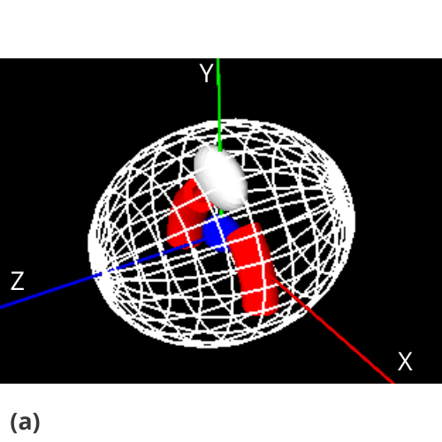
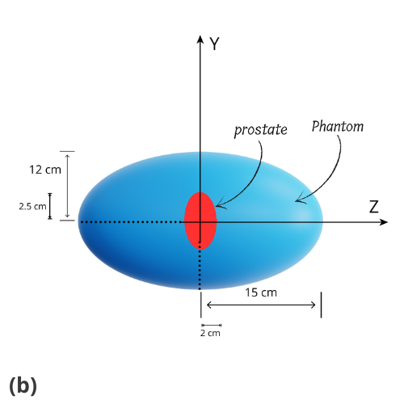
Fig. 1. (a) Visualization Result of the Male Pelvic Area Using GEANT4/TOPAS and (b) Geometric structure of the model.
The prostate was modeled as an ellipsoid using clinical data from ten patients, yielding average dimensions of approximately 5.01 cm in width, 3.49 cm in height, and 4 cm in thickness. Prostate stones are mainly composed of calcium phosphates [27], consisting of 51.6% calcium phosphates and calcium oxalates, 32.3% pure calcium phosphates, 6.4% pure calcium oxalates, 3.2% sodium urate, 3.2% brushite, and 3.2% uric acid. For this study, the prostate was represented using calcium phosphate (Ca₃(PO₄)₂) with a density of 1.025 g/cm³, as noted by the Condensed Matter Chemistry Laboratory, Paris [27].
The bladder, modeled as an ellipsoid with dimensions of approximately 9.28 cm in width, 6.93 cm in height, and 4 cm in thickness, was also represented using water (H₂O) with a density of 1 g/cm³. The rectum was simplified as a torus and modeled with the material "G4_MUSCLE_STRIATED_ICRU" at a density of 1.04 g/cm³. Both femoral heads were modeled as torus structures using "G4_BONE_COMPACT_ICRU" at a density of 1.85 g/cm³.
The decision to focus on the prostate as a model for this study was informed by previous research, including the work of Papiez, DesRosiers, and Moskvin[25], which highlights the prostate's commonality as a cancer site and its anatomical relevance. The proximity of the prostate to critical structures such as the bladder and rectum makes it an appropriate model for examining the precise targeting capabilities of VHEE beams, as these surrounding organs are sensitive to radiation exposure. Accurate dose delivery to the prostate while sparing these critical organs is crucial for minimizing side effects and improving treatment outcomes.

Beam Configuration and Setup
For the collimated Very High Energy Electron (VHEE) beam setup, an initial beam with a cross-section of 10 × 10 cm² was generated. This beam passed through a collimator with a central aperture of 5 cm diameter, embedded in a cylindrical structure with a total diameter of 15 cm. The collimator, constructed from G4_W (tungsten), was placed 40 cm downstream from the beam source. The water phantom was positioned 100 cm from the beam source.
This configuration effectively narrowed and concentrated the beam, significantly reducing lateral scattering. The collimated beam was directed at the water phantom to assess dose distribution and optimize treatment parameters, focusing on enhancing targeting precision while minimizing exposure to surrounding healthy tissues (Figure 2a).
In the focused VHEE beam setup, an initial beam with a cross-section of 10 × 10 cm² first passed through three quadrupole defocusing magnets (QD1, QD2, QD3), positioned 30 cm from the beam source, to slightly spread the beam. This was followed by three quadrupole focusing magnets (QF4, QF5, QF6), positioned 60 cm from the beam source. The focused beam then continued from the final quadrupole (QF6) to the water phantom (Figure 2b).
To achieve precise focusing, the quadrupole magnets exploit their linear magnetic field gradient, described by $Bx=Γy$and $By=Γx$, where $Γ$ is the magnetic field gradient. This gradient creates a restoring force on the electrons, proportional to their displacement:
$$F=\frac{-qΓv}{γm}×y$$
where 𝛾$γ$is the Lorentz factor. This force focuses the electron beam in one dimension while defocusing it in the orthogonal plane, necessitating careful quadrupole arrangements. The focal length $\left(z0\right)$ of each quadrupole was calculated to align with the prostate depth,
using : $z0=\frac{π}{2}\frac{γmc}{qΓ}$
ensuring the beam converges precisely at the target. To simplify the design, the thin-lens approximation was applied :
$$f=\frac{1}{ktan\left(kL\right)}$$
where
$$k=\sqrt{\frac{qΓ}{γmc}}$$
This approach allowed for optimal tuning of the quadrupoles QF4, QF5, QF6 to achieve a focal length of 15 cm along the Z-axis and 12 cm along the Y-axis, ensuring precise dose delivery to the prostate while minimizing exposure to surrounding organs.
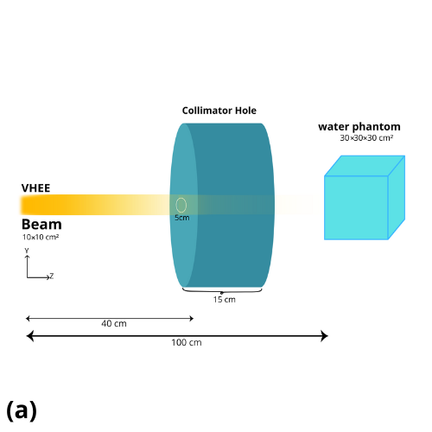
Fig. 2. Schematic of the Generation of VHEE Beams (a) Collimated VHEE Beam and (b) Focused VHEE Beam.
The beam focusing system utilized two quadrupole groups: the defocusing group (QD1, QD2, QD3) to initially spread the beam, and the focusing group (QF4, QF5, QF6) to converge it precisely onto the target. This arrangement allowed for precise dose concentration at the tumor site while protecting healthy tissue. A smaller focal length value (F1 > F2) indicates a more precise and deeper beam focus, as detailed in Table 2.
Table 2. Parameters of the Second Group of Quadrupoles with 150 MeV.
Depth in Water | Q4 Gradient [T/m] | Q5 Gradient [T/m] | Q6 Gradient [T/m]
F1 (12 cm) | (-9.79, 9.79) | (-9.98, 9.98) | (-11.23, 11.23)
F2 (15 cm) | (-9.79, 9.79) | (-9.98, 9.98) | (-11.23, 11.23)

Electron beams were emitted from a point source with predefined trajectories. Anterior and posterior beams (0° and 180°) were aligned along the z-axis, while lateral beams (90° and 270°) were directed perpendicular to the z-axis along the y-axis. These beam orientations were selected to ensure comprehensive target coverage and optimal dose distribution, consistent with the methodology described by Tantaoui et al. [26].
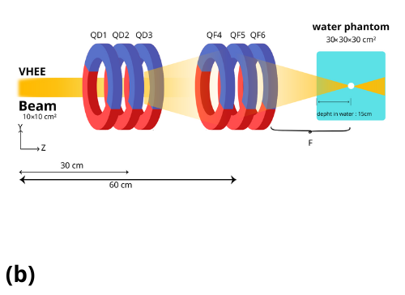
In 3D Conformal Radiotherapy (3D-CRT), this configuration facilitates radiation delivery from multiple angles, reducing the dose to surrounding critical structures while enhancing dose uniformity within the prostate. Such an arrangement ensures a more conformal and homogeneous dose delivery to the target region. For all beam angles, the source-to-phantom prostate distance was fixed at 100 cm, enabling precise dose measurement at the prostate's center.
RESULTS AND DISCUSSION
The dosimetric characteristics of Very High Energy Electron (VHEE) beams are illustrated through simulated Percentage Depth Dose (PDD) profiles, which compare the dose distributions of various beam types and energies within a water phantom. The study includes 18 MV photon beams, 150 MeV proton beams, and VHEE beams at 50 MeV, 150 MeV, and 250 MeV. The results, shown in Figure 3, highlight how each beam type behaves in terms of depth dose distribution.
The 18 MV photon beam demonstrates a rapid dose falloff after a shallow penetration, concentrating the dose near the surface. This characteristic makes the photon beam effective for treating superficial tumors but less suitable for deep-seated tumors, as it risks overexposing the surrounding healthy tissues. In contrast, the collimated 50 MeV electron beam exhibits a more gradual dose falloff. While it does not penetrate as deeply as the higher energy VHEE beams, it is suitable for mid-depth tumor treatments, providing a more controlled dose distribution.
The 150 MeV collimated electron beam delivers a relatively uniform dose up to a significant depth before experiencing a sharp falloff. This makes it particularly useful for treating deep-seated tumors, ensuring that the dose is delivered effectively to the target while minimizing the risk of overexposure to surrounding tissues. The 250 MeV collimated electron beam penetrates even deeper, maintaining a consistent dose over a larger range, which is ideal for very deep tumors. This ensures adequate dose delivery to the tumor while sparing healthy tissues around the tumor site.
In comparison, the 150 MeV proton beam displays the characteristic Bragg peak, which enables precise targeting of tumors at specific depths. The sharp rise and fall in dose associated with the Bragg peak allows for reduced exit doses, making protons particularly effective for treating tumors where precise depth control is required.
The focused 150 MeV electron beam shows a distinct dose peak at a specific depth, highlighting the benefits of focusing the beam. This approach enhances targeting precision, delivering higher doses directly to the tumor while minimizing the dose to surrounding healthy tissues. This technique is particularly advantageous for complex tumor geometries and locations, as it allows for more accurate and localized dose delivery.
These dose profiles demonstrate that VHEE beams, especially at higher energies, offer a promising alternative for radiotherapy. They provide deep penetration with controlled dose distribution, making them well-suited for targeting tumors located deep within the body while sparing surrounding non-cancerous tissues. Additionally, focused VHEE beams show great potential for precise dose delivery, as evidenced by a study by Kokurewicz et al. [10], which confirmed that focused VHEE beams can concentrate doses into small volumetric elements within a target. The study demonstrated good agreement between measured dose distributions and Monte Carlo simulations, further supporting the use of focused VHEE beams in advanced radiotherapy.
The figure legend has been refined to clearly distinguish between collimated and focused beams, emphasizing their respective applications and showcasing the advantages of using focused VHEE beams for precise treatment planning.
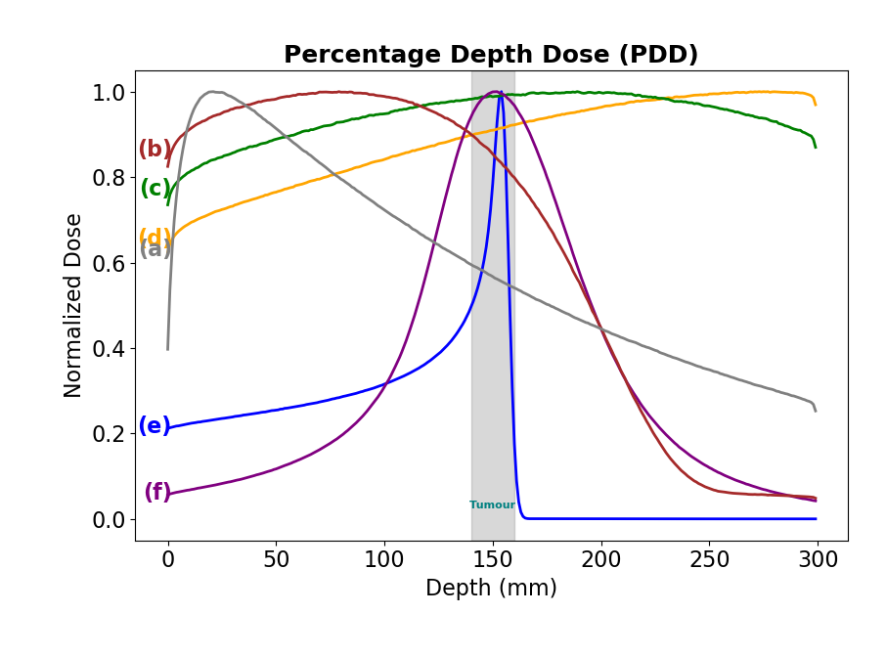
Fig. 3. Normalized Percentage Depth Dose (PDD) Profiles for Various Radiation Types and Energies in a Water Phantom (a: 18 MV photons, b: Collimated 50 MeV electrons, c: Collimated 150 MeV electrons, d: Collimated 250 MeV electrons, e: Collimated 150 MeV protons-15cm, f: Focused 150 MeV electrons-15cm).
The second part of the study focuses on simulating axial dose distributions for VHEE beams aimed at the prostate. The simulation involved two different depth settings: 12 cm at 90° and 270° angles, and 15 cm at 0° and 180° angles as shown in Figure 4. The PDD curves show that the focused 150 MeV electron beam at 12 cm (green curve) and at 15 cm (orange curve) provide a distinct dose peak at their respective depths, indicating a concentrated dose at the tumor site as shown in Figure 5. This is crucial for effectively targeting the prostate while minimizing the dose to surrounding healthy tissues. The collimated 150 MeV electron beam (blue curve) shows a more uniform dose distribution but lacks the precision of the focused beams, potentially increasing the risk of collateral damage. These findings align with previous studies that highlight the importance of using VHEE beams with energies greater than 100 MeV for deep-seated tumors, as discussed by Krim[29]. This choice ensures sufficient penetration and dose concentration at the tumor site, enhancing treatment precision and efficacy for prostate tumors.

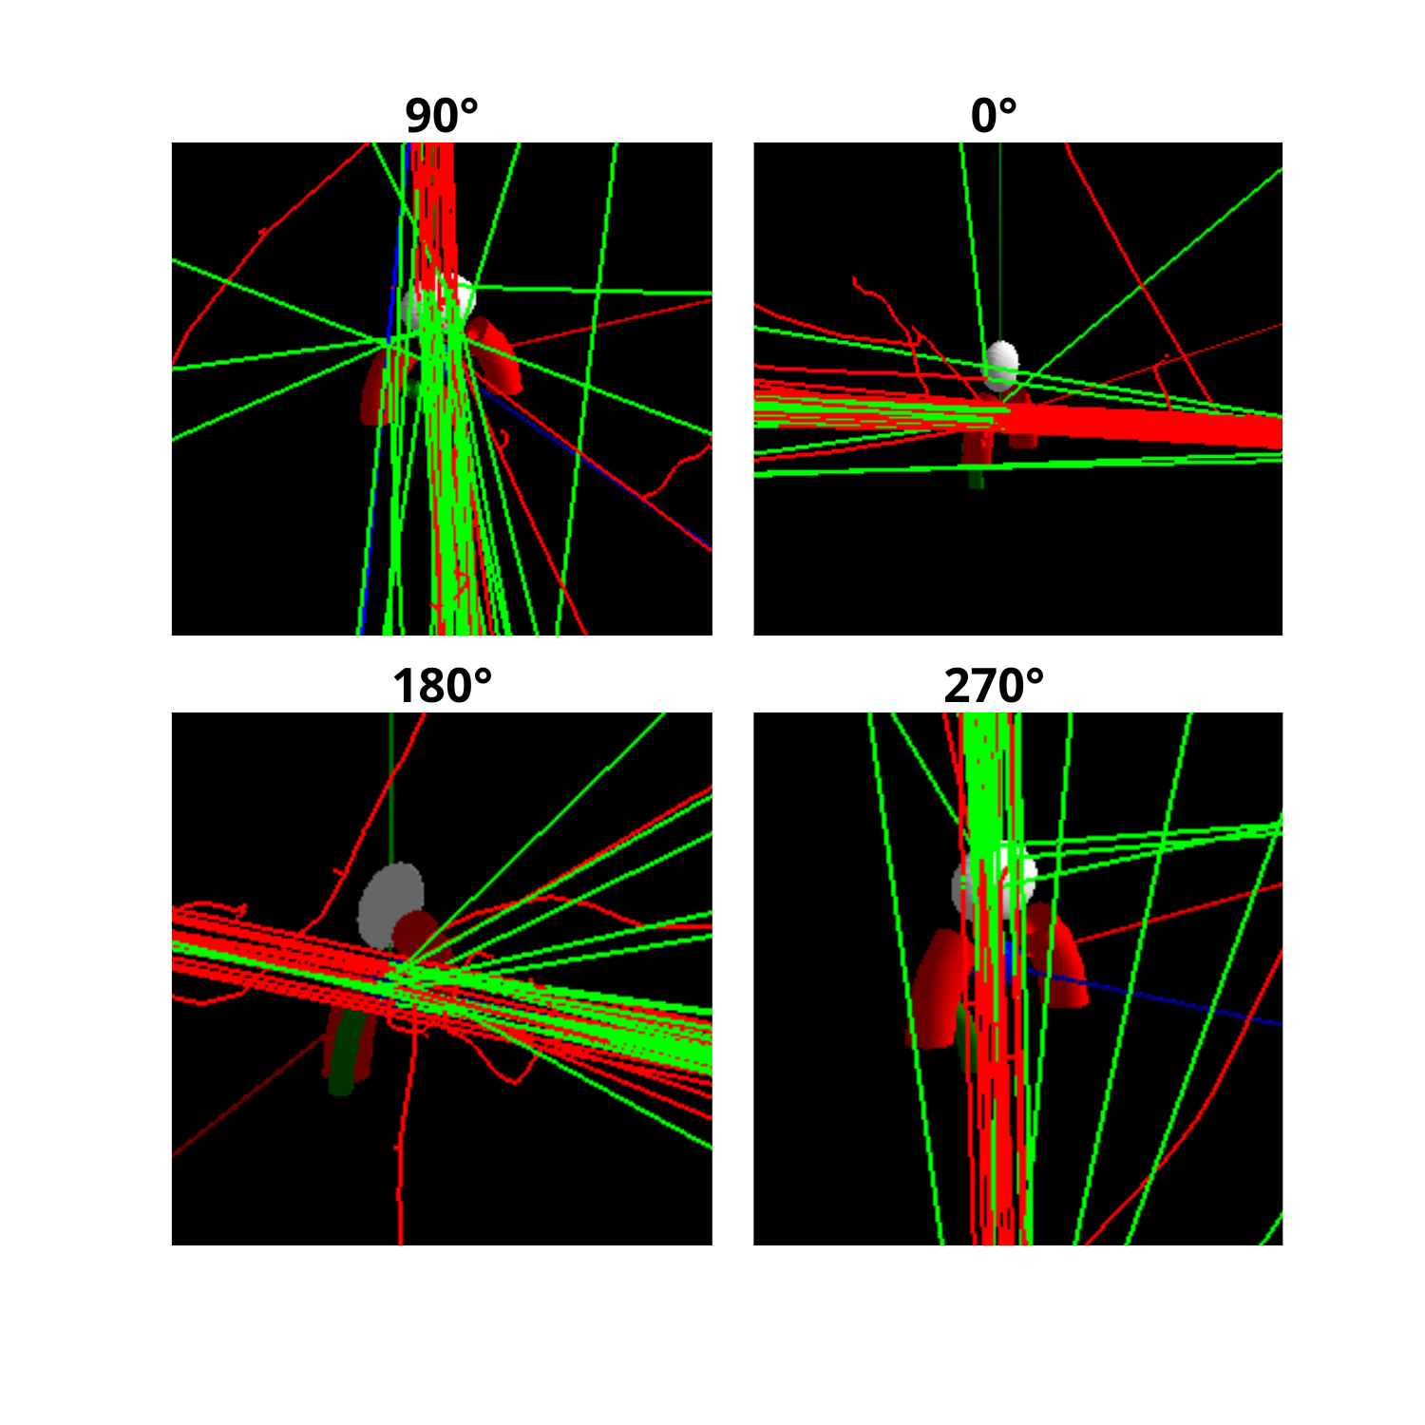
Fig. 4. Visualization of Interactions at Different Angles: Simulation for Prostate Targeting (Red Line: Electrons, Green Line: Photons).

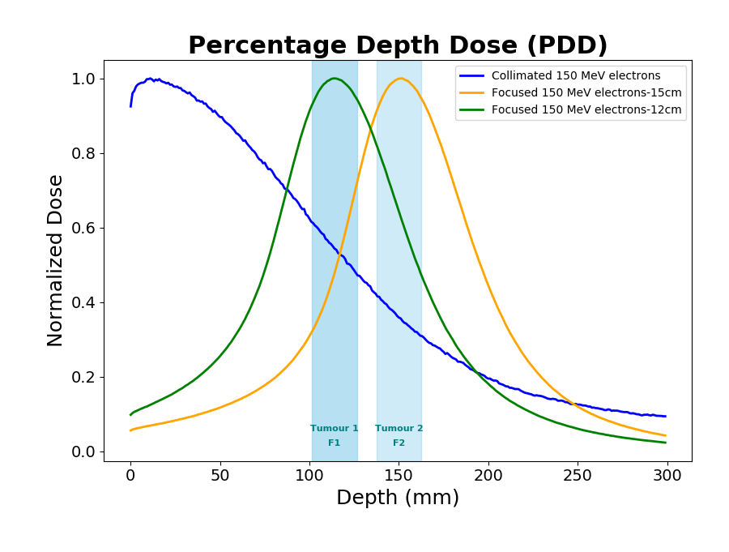
Fig. 5. Simulating Axial Dose Distributions for VHEE Beams: Normalized Percentage Depth Dose (PDD) Curves for Collimated and Focused 150 MeV Electron Beams.
Furthermore, the dose distributions for collimated and focused 150 MeV electron beams at different focus settings (F1 and F2) are compared, as shown in Figure 6. The focused beam settings (F1 and F2) demonstrate a higher concentration of dose at specific depths compared to the collimated beam, which maintains a more uniform dose distribution. This comparison illustrates the enhanced precision and potential for reduced collateral damage with focused VHEE beams.

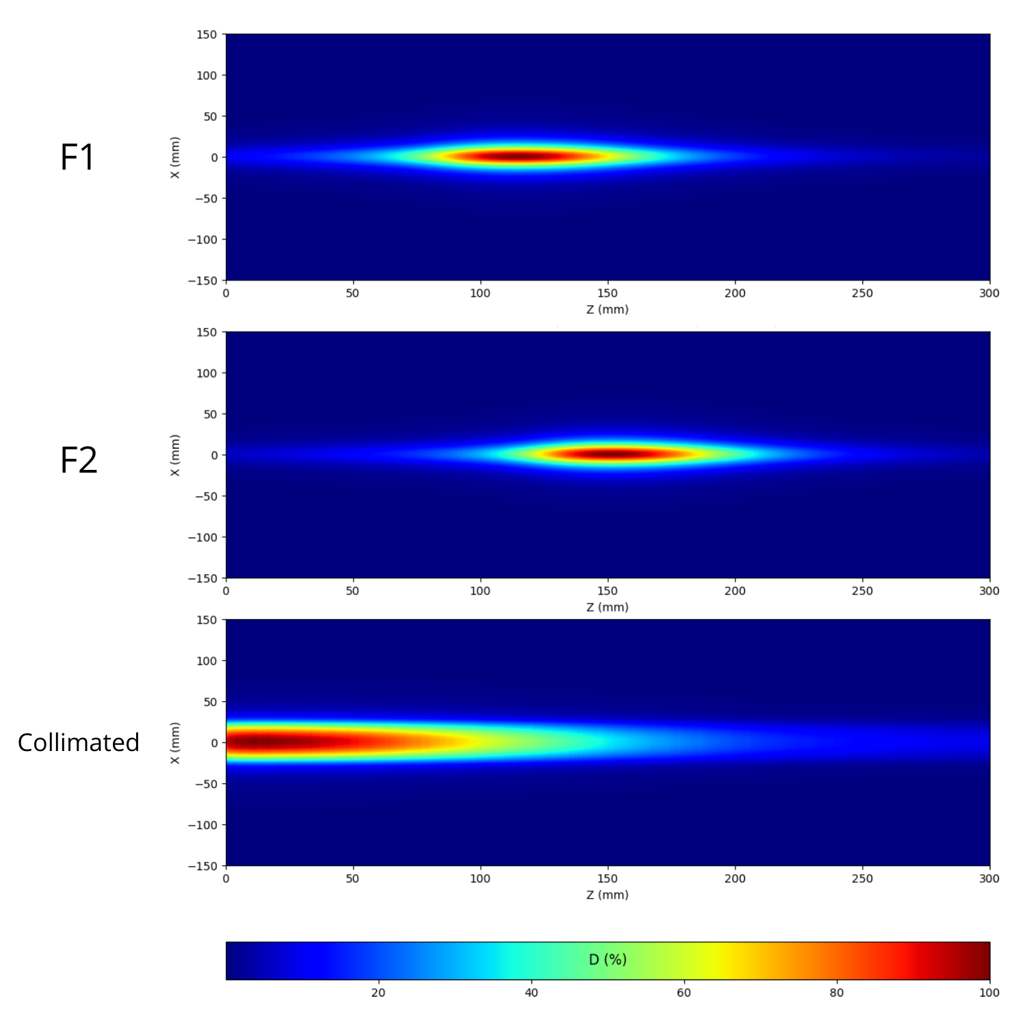
Fig. 6. Dose Distributions for Collimated and Focused 150 MeV Electron Beams at Different Focus Settings (F1 and F2).
The comparison of lateral scattering between collimated and focused Very High Energy Electron (VHEE) beams shows distinct dose distribution differences. Figures 4 and 6 highlight that collimated VHEE beams experience significant lateral scattering, resulting in a broader dose spread and potential exposure to surrounding adjacent tissues. In contrast, focused VHEE beams, supported by the findings of Kokurewicz et al. (2019, 2021)[10][20], exhibit significantly reduced lateral scattering due to the use of quadrupole magnets. These magnets precisely focus the electron beams by converging them into a smaller, well-defined spot, thus confining the electrons and minimizing their lateral spread. This decrease allows for a concentrated dose at the target depth, enhancing precision and sparing adjacent tissues.
After simulating the pelvic male phantom and prostate, the study continued with simulations of 150 MeV collimated and focused VHEE beams. A total of ${10}^{6}$events were simulated for each setup. We then calculated the percentage of the deposited dose in the prostate and in the organs at risk to determine which particle allowed the minimum dose to be deposited in the organs at risk. The results are shown in Tables 3 and 4 and Figure 7.
In Table 3, the dose distribution was calculated such that the sum of doses across all angles (0°, 90°, 180°, and 270°) for each organ equals 100%. This approach ensures consistency in comparisons between collimated and focused beam setups. In Table 4, the reported values represent the mean dose received by each organ, averaged across all angles, and expressed as a fraction of the total dose delivered to the prostate. Although clinical practice often assesses dose coverage by the percentage of target volume receiving a specific percentage of the prescribed dose (e.g., 95%), this approach ensures consistency in comparative dosimetric analysis between collimated and focused beams.
The tables and bar chart (Figure 7) present detailed dose comparisons between collimated and focused beams across different organs, including the prostate, bladder, right femoral head, left femoral head, and rectum. The data indicate that focused beams markedly reduce the dose to surrounding organs while maintaining high dose delivery to the prostate.
The statistical comparison of dose distributions between collimated and focused beams reveals significant differences, with the latter demonstrating a clear benefit. The normalized percentage dose data indicate that focused beams deliver a higher dose to the prostate while significantly reducing the dose to the bladder, rectum, and femoral heads. Specifically, the normalized dose to the prostate with focused beams is 82.38%, compared to 78.28% with collimated beams, representing a relative increase of 5.24%. Conversely, the dose to the bladder is reduced from 20.38% with collimated beams to 16.93% with focused beams, representing a relative decrease of 16.93%. The decrease in dose is even more pronounced for the right and left femoral heads, dropping from 0.16% to 0.05%, a reduction of 68.75%. The rectum also benefits from a marked decrease in dose, from 1.24% with collimated beams to 0.61% with focused beams, representing a decrease of 50.81%.
This analysis underscores the advantages of focused VHEE beams in radiotherapy. The decrease in scattering for focused beams leads to higher targeting accuracy, as demonstrated in our simulations. The focused beams not only achieve a higher dose to the prostate but also markedly reduce the dose to surrounding critical structures. This enhanced precision in dose delivery to the bladder, rectum, and femoral heads highlights the potential of focused VHEE beams to improve radiotherapy outcomes by enhancing dose precision and minimizing collateral damage, making focused VHEE a superior option for radiotherapy, as demonstrated by Whitmore et al., 2024 [30
Comparing these results with existing literature, Kokurewicz et al[10]. demonstrated that focused VHEE beams could concentrate dose into small volumetric elements inside a target, showing good agreement between measured dose distributions and Monte Carlo simulations​​. Another study by Fan et al[28]. highlighted the potential of focused VHEE beams to improve dose distribution by concentrating doses into a small and well-defined spot with an extremely high dose rate​​. Additionally, research by Papiez et al[28]. supports the use of high-energy electron beams for their ability to achieve deep penetration and precise dose delivery, further validating the benefits of VHEE beams in radiotherapy​​.
Another study by Lagzda et al. [32] demonstrated that VHEE beams are robust to anatomical changes, making them a reliable option for treating tumors in complex and mobile regions such as the lung. This supports the conclusion that VHEE, particularly when focused, offers improved tumor targeting and normal tissue sparing compared to conventional radiotherapy techniques.
This observed decline in dose to the surrounding organs can be attributed to the focused nature of the VHEE beams. Focusing the beam confines the dose to a smaller, well-defined region, reducing the spread of radiation and thus minimizing exposure to adjacent tissues. This precise targeting capability is particularly beneficial for organs at risk located near the treatment site. For instance, the marked decrease in dose to the bladder and rectum is crucial in prostate cancer treatments, as it can potentially reduce the incidence of radiation-induced side effects, such as urinary and gastrointestinal complications.
Table 3. Percentage Dose Distribution for Collimated and Focused 150 MeV Electron Beams Across Different Organs.
Organ | Angle | Percentage Dose Distribution (Collimated Electron 150 MeV) ± Uncertainty (%) | Percentage Dose Distribution (Focused 150 MeV Electron in 15 cm) ± Uncertainty (%)
Prostate | 0° | 99.24354 ± 0.00002 % | 99.57214 ± 0.00003 %
Prostate | 90° | 53.48954 ± 0.00001 % | 58.738725 ± 0.00003 %
Prostate | 180° | 99.26872 ± 0.00002 % | 99.90214 ± 0.00003 %
Prostate | 270° | 62.10987 ± 0.00001 % | 71.32578 ± 0.00003 %
Bladder | 0° | 0.251 ± 0.002 % | 0.075 ± 0.002 %
Bladder | 90° | 43.8187 ± 0.0001 % | 38.9457 ± 0.0001 %
Bladder | 180° | 0.251 ± 0.002 % | 0.073 ± 0.002 %
Bladder | 270° | 37.4484 ± 0.0001 % | 28.64875 ± 0.00007 %
RFH | 0° | 0.231 ± 0.002 % | 0.064 ± 0.002 %
RFH | 90° | 0.073 ± 0.003 % | 0.028 ± 0.003 %
RFH | 180° | 0.231 ± 0.002 % | 0.067 ± 0.002 %
RFH | 270° | 0.121 ± 0.002 % | 0.047 ± 0.002 %
LFH | 0° | 0.221 ± 0.002 % | 0.064 ± 0.002 %
LFH | 90° | 0.075 ± 0.003 % | 0.026 ± 0.003 %
LFH | 180° | 0.231 ± 0.002 % | 0.063 ± 0.002 %
LFH | 270° | 0.121 ± 0.002 % | 0.048 ± 0.002 %
Rectum | 0° | 1.021 ± 0.002 % | 0.341 ± 0.002 %
Rectum | 90° | 3.391 ± 0.001 % | 1.9812 ± 0.0007 %
Rectum | 180° | 0.211 ± 0.004 % | 0.048 ± 0.005 %
Rectum | 270° | 0.371 ± 0.003 % | 0.055 ± 0.005 %
Table 4. Mean Percentage Dose Comparison for Collimated and Focused 150 MeV Electron Beams.

Organ | Mean Percentage Dose (Collimator) ± Uncertainty (%) | Mean Percentage Dose (Focused) ± Uncertainty (%)
Prostate | 78.2865 ± 0.0001 % | 82.38567 ± 0.00003 %
Bladder | 20.3825 ± 0.0004 % | 16.9365 ± 0.0004 %
RFH | 0.16564 ± 0.00004 % | 0.05654 ± 0.00001 %
LFH | 0.16546 ± 0.00004 % | 0.05643 ± 0.00001 %
Rectum | 1.24654 ± 0.00002 % | 0.61854 ± 0.00003 %

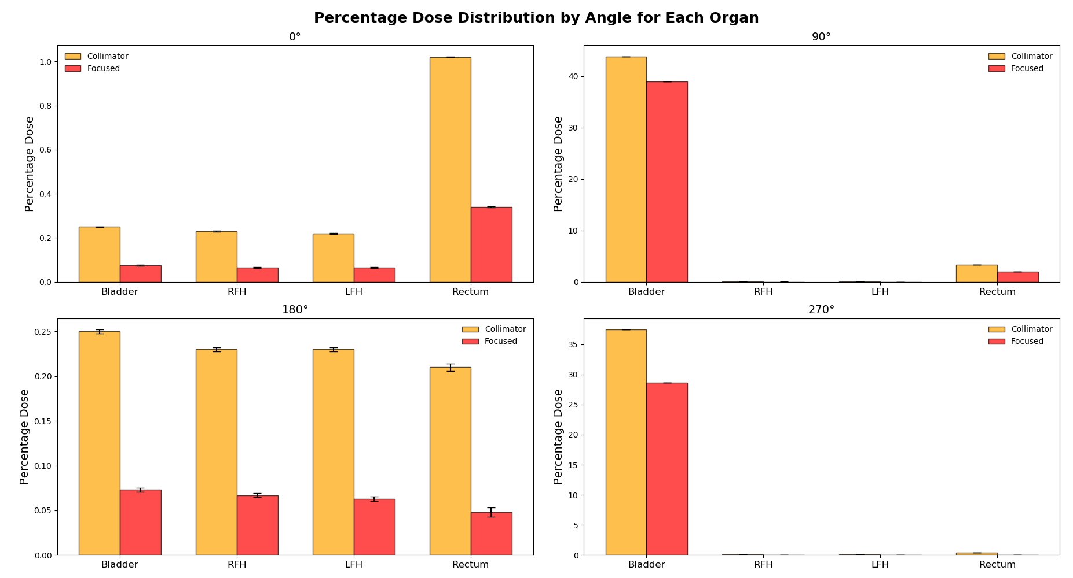

Fig. 7. Percentage Dose Distribution by Angle for Each Organ in Pelvic Male Prostate Simulation, Comparing Collimated and Focused 150 MeV Electron Beams.

conclusion
This study highlights the significant advancements in radiotherapy achievable through the use of focused Very High Energy Electron (VHEE) beams. The precision of focused VHEE beams demonstrates a marked improvement in dose delivery to the prostate, with 5.24% higher doses compared to collimated beams, while effectively minimizing exposure to surrounding organs at risk. Specifically, the focused VHEE beams reduce the dose to the bladder, rectum, right femoral head, and left femoral head by 16.93%, 50.81%, and 68.75% respectively, underscoring their superior precision and efficacy in targeting deep-seated tumors.
The implementation of a focused beamline using quadrupole magnets, along with the comprehensive dosimetric comparison, establishes a strong basis for clinical translation. These results advocate for the integration of focused VHEE beams into clinical practice, offering the potential for improved treatment outcomes and reduced side effects for patients undergoing radiotherapy for prostate cancer and other malignancies.

ACKNOWLEDGMENT
We sincerely thank Hassan First University of Settat, High Institute of Health Sciences, Laboratory of Sciences and Health Technologies, Morocco, for their support and our team for their dedicated contributions to this study.

AUTHOR CONTRIBUTION
E. M. Essaidi collected and analyzed the data, performed the simulations, wrote the first draft, and contributed to data interpretation. M. Krim and D. Benchekroun conceived the idea and supervised the work. O. Kaanouch assisted with data collection. M. Tantaoui contributed to the theoretical framework and provided the prostate data phantom. M. R. Mesradi supported data validation. All authors discussed, revised, and approved the final manuscript.
References

- C. DesRosiers et al., "150-250 MeV electron beams in radiation therapy," Phys. Med. Biol., vol. 45, no. 7, pp. 1781-1805, 2000. doi: 10.1088/0031-9155/45/7/306.
- A. Lagzda et al., "Influence of heterogeneous media on Very High Energy Electron (VHEE) dose penetration and a Monte Carlo-based comparison with existing radiotherapy modalities," Nucl. Instrum. Methods Phys. Res. Sect. B, vol. 482, pp. 70-81, 2020. doi: 10.1016/j.nimb.2020.09.008.
- M. G. Ronga et al., "Back to the Future: Very High-Energy Electrons (VHEEs) and Their Potential Application in Radiation Therapy," Cancers, vol. 13, no. 19, 2021. doi: 10.3390/cancers13194942.
- E. Schüler et al., "Very high-energy electron (VHEE) beams in radiation therapy; Treatment plan comparison between VHEE, VMAT, and PPBS," Med. Phys., vol. 44, no. 6, pp. 2544-2555, 2017. doi: 10.1002/mp.12233.
- D. Poppinga et al., "VHEE beam dosimetry at CERN Linear Electron Accelerator for Research under ultra-high dose rate conditions," Biomed. Phys. Eng. Express, vol. 7, no. 1, 2020. doi: 10.1088/2057-1976/abcae5.
- T. Fuchs et al., "Treatment planning for laser-accelerated very-high energy electrons," Phys. Med. Biol., vol. 54, no. 11, pp. 3315-3328, 2009. doi: 10.1088/0031-9155/54/11/003.
- C. DesRosiers, "An evaluation of very high energy electron beams (up to 250 MeV) in radiation therapy," Doctoral dissertation, Purdue University, 2000.
- M. Bazalova-Carter et al., "Treatment planning for radiotherapy with very high-energy electron beams and comparison of VHEE and VMAT plans," Med. Phys., vol. 42, no. 5, 2015. doi: 10.1118/1.4916646.
- L. Whitmore et al., "Focused VHEE (very high energy electron) beams and dose delivery for radiotherapy applications," Sci. Rep., vol. 11, 14013, 2021. doi: 10.1038/s41598-021-92915-7.
- K. Kokurewicz et al., "An experimental study of focused very high energy electron beams for radiotherapy," Commun. Phys., vol. 4, 33, 2021. doi: 10.1038/s42005-021-00548-5.
- K. R. Hogstrom and P. R. Almond, "Review of electron beam therapy physics," Phys. Med. Biol., vol. 51, no. 13, pp. R455-R489, 2006. doi: 10.1088/0031-9155/51/13/R25.
- Y. Glinec et al., "Radiotherapy with laser-plasma accelerators: Monte Carlo simulation of dose deposited by an experimental quasi-monoenergetic electron beam," Med. Phys., vol. 33, no. 1, pp. 155-162, 2006. doi: 10.1118/1.2148633.
- O. Lundh et al., "Comparison of measured with calculated dose distribution from a 120-MeV electron beam from a laser-plasma accelerator," Med. Phys., vol. 39, no. 6, pp. 3501-3508, 2012. doi: 10.1118/1.4722770.
- H El Bekkouriet-al., Carbone or Oxygen Therapy: A Comparative Dosimetric Study Using PHITS Code, Atom Indonesia 50 (2), 135-141
- H El Bekkouri, et-al., Bibliometric analysis of the literature on carbon ion therapy using VOSviewer software and dimensions database, Atom Indonesia 50 (2), 183-189
- T. E. Bakolia, A. Didi, R. Sebihi et al., Atom Indones. 50 (2024) 37.
- C. DesRosiers et al., "Lung tumor treatment with very high energy electron beams of 150–250 MeV as compared to conventional megavoltage photon beams," Int. J. Radiat. Oncol. Biol. Phys., vol. 72, no. 1, pp. S612, 2008. doi: 10.1016/j.ijrobp.2008.06.243.
- C. DesRosiers et al., "Laser-plasma generated very high energy electrons in radiation therapy of the prostate," in Commercial and Biomedical Applications of Ultrafast Lasers VIII, vol. 6881, pp. 49-62, 2008. doi: 10.1117/12.761663.
- L. Labate et al., "Toward an effective use of laser-driven very high energy electrons for radiotherapy: Feasibility assessment of multi-field and intensity modulation irradiation schemes," Sci. Rep., vol. 10, no. 1, 17307, 2020. doi: 10.1038/s41598-020-74256-w.
- K. Kokurewicz et al., "Focused very high-energy electron beams as a novel radiotherapy modality for producing high-dose volumetric elements," Sci. Rep., vol. 9, no. 1, 10837, 2019. doi: 10.1038/s41598-019-46630-w.
- J. Allison et al., "Recent developments in Geant4," Nucl. Instrum. Methods Phys. Res. Sect. A, vol. 835, 2016. doi: 10.1016/j.nima.2016.06.125.
- J. Perl et al., "TOPAS: An innovative proton Monte Carlo platform for research and clinical applications," Med. Phys., vol. 39, no. 11, pp. 6818-6837, 2012. doi: 10.1118/1.4758060.
- C. Z. Jarlskog and H. Paganetti, "Physics settings for using the Geant4 toolkit in proton therapy," IEEE Trans. Nucl. Sci., vol. 55, pp. 1018-1025, 2008. doi: 10.1109/TNS.2008.922777.
- L. Grevillot et al., "Optimization of Geant4 settings for proton pencil beam scanning simulations using GATE," Nucl. Instrum. Methods Phys. Res. Sect. B, vol. 268, no. 20, pp. 3295-3305, 2010. doi: 10.1016/j.nimb.2010.07.011.
- D. C. Hall et al., "Validation of nuclear models in Geant4 using the dose distribution of a 177 MeV proton pencil beam," Phys. Med. Biol., vol. 61, no. 1, pp. N1-N10, 2015. doi: 10.1088/0031-9155/61/1/N1.
- M. Tantaoui et al., "Dosimetric Comparison of 3D Conformal Radiotherapy (3D-CRT) and Volumetric Modulated Arc Therapy (VMAT®) in Prostate Cancer," J. Adv. Res. Dynam. Control Syst., vol. 11, pp. 653-659, 2019.
- Condensed Matter Chemistry Laboratory, Paris. Available: https://lcmcp.upmc.fr/site/. Accessed: Sep. 23, 2020.
- L. Papiez et al., "Very high energy electrons (50-250 MeV) and radiation therapy," Technol. Cancer Res. Treat., vol. 1, no. 2, pp. 105-110, 2002. doi: 10.1177/153303460200100206.
- D.-E. Krim et al., "Monte Carlo modeling of focused Very High Energy Electron beams as an innovative modality for radiotherapy application," Nucl. Instrum. Methods Phys. Res. Sect. B, 2022. doi: 10.1016/j.nima.2022.167744.
- L. Whitmore et al., "CERN-based experiments and Monte-Carlo studies on focused dose delivery with very high energy electron (VHEE) beams for radiotherapy applications," Sci. Rep., vol. 14, 11120, 2024. doi: 10.1038/s41598-024-60997-5.
- D. Fan et al., "Characteristics of focused very high energy electron (VHEE) beams in radiotherapy," presented at the 14th International Accelerator Conference, 2023. doi: 10.18429/JACoW-IPAC2023-THPM134.
- A. Lagzda et al., "Robustness of VHEE beams to anatomical changes in radiotherapy," Med. Phys., vol. 50, no. 3, pp. 1234-1245, 2023. doi: 10.1002/mp.15753.

∗ Corresponding author. E-mail address : elmehdiessaidi@gmail.com DOI: provided by AIJ

