TEMPERATURE AND STRETCHING EFFECTS ON COMPLEMENTARITY DETERMINING REGION’S (CDRs) CONFORMATION AND STABILITY OF NIMOTUZUMAB F(ab)-FRAGMENT
Atom Indonesia

T.S. Humani^{1,2*}, M.A. Martoprawiro², A. Mutalib³
¹Center for Radioisotopes and Radiopharmaceutical Technology, National Nuclear Energy Agency of Indonesia, Puspiptek Area 11st Building, Tangerang 15310, Indonesia
²Department of Computational Science, Faculty of Science, Bandung Institute of Technology, Ganesha 10, Bandung 40132, Indonesia
³Department of Chemistry, Faculty of Mathematics and Natural Science, Padjajaran University, Bandung 40133, Indonesia

A R T I C L E I N F O a B S T R A C T

AIJ use only:  Received date  Revised date  Accepted date  Keywords:  Nimotuzumab  F(ab)-Nimotuzumab  Complementarity Determining Regions (CDRs)  Unfolding  Molecular Dynamics  Steered Molecular Dynamics |  | Nimotuzumab is a humanized monoclonal antibody (mAb), a potential anticancer against epidermal growth factor receptor (EGFR) overexpressed by glioma, head and neck, lung, ovarium, and colon cancers. The combination of the use of it with both external and internal beam radiotherapies showed improvement of the therapeutic effect. However, the high molecular weight make it has a slow uptake on tumor cells. Recent development, nimotuzumab has been fragmented, and then labeled using diagnostic and therapeutic radionuclides, such as gallium-68, yttrium-90, lutetium-177, holmium-166, etc.. In that preparation, nimotuzumab is often conditioned in various environments with variations of pH, temperature and the presence of other compounds. In this research, molecular dynamics (MD) simulation have been carried out to study the conformational change of CDRs nimotuzumab due to the effect of temperature, and also steered molecular dynamics (SMD) simulation to study the stability of domain nimotuzumab as a result of external forces. The simulations were performed using the Not Just Another Molecular Dynamics (NAMD) program package and the analysis was performed with the Visual Molecular Dynamics (VMD) package program. Based on the stability analysis of each residue on the heavy chain, the active site (CDR3 region) that is at residues numbered 98 (Tryptophan) and 99 (Phenyl Alanine) has the highest conformational changes. On the light chain, the change occurs at residues numbered 1 (Aspartat), 127 (Serin), and 186 (Tyrosine); and that none of that residues is part of active site or CDRs region of the light chain. The SMD simulation was carried out by fixing the N-terminal end of the heavy chain and applying external forces to the C-terminal end. The pulling was set at a constant velocity of 0.5 Å/ps. The force peak arising at the begining of the unfolding process is 1226 pN. This force was allegedly caused by the rupture of hydrogen bonds between heavy chain residue VAL211 (Valine) and heavy chain residue TYR194 (Tyrosine).  © 2014 Atom Indonesia. All rights reserved

Introduction∗

Cancer represents one of the leading causes of death in the world and lung cancer is the most common cause of cancer-related death worldwide, in which non-small cell lung cancer reaches 75% of all lung cancer cases [1]. According to WHO, in 2008 there were 7.5 million deaths caused by cancer, and 70% of which occur in developing countries. Because of the high number of deaths caused by cancer, various studies of clinical treatments of cancer therapy have been conducted. However, the widely and commonly used therapies by means of surgery, radiotherapy and chemotherapy have still not provided very satisfactory results, particularly in addition to some adverse side effects to the cancer patients [2]. Ongoing research is directed to targeted therapy using biomolecules, such as monoclonal antibody, that is able to specifically interact with target molecules, such as receptor, antigen, etc., that over-expressed by cancer cells. Mechanism of action of monoclonal antibodies is usually preceded by their interaction through non-covalent bonds with the receptors in the surface of cancer cell membran in the body. It appears that the cell surface of non-small cell lung cancer overexpress Epidermal Growth Factor Receptor (EGFR), as well as breast cancer, glioma, colon cancer and head and neck cancer [3]. The EGFR belongs to the family of tyrosine kinase receptors (RTKs). Over-expression of EGFR is often associated with cancer malignancy and plays a significant role in tumor development and progression, including cell proliferation, regulation of apoptotic cell death, angiogenesis, and metastatic spread. Therefore, one of the methods used for the cancer therapy is to inhibit the effects of EGFR activation, with the aim of blocking tumor growth and invasion, using either specific antibodies directed against its ligand-binding domains or small molecules inhibiting its tyrosine kinase activity.
Nimotuzumab or also called h-R3 is a humanized monoclonal antibody specific to EGFR and is one of the alternative cancer therapeutic agent. Although not included in the 12 antibodies that have been approved by the Food and Drug Administration (FDA), the use of nimotuzumab would be interesting because of side effects such as skin rash which was not found [3,4]. This is in contrast to other uses of monoclonal antibodies targeting EGFR that cause skin rashes in every use [5].
Since several years ago metal-radionuclides labeled nimotuzumab has been developed as target-spesific radiopharmaceuticals that is commonly called as radioimmnotherapeutic agents or radimmunodiagnostic agents if labeled with therapeutic or diagnostic radionuclides, respectively, using a bifungtional chelating agent (BFCA). The BFCA could form both stable metal radionuclide complexes and immunoconjugates with antibodies and peptides. In general, the process of conjugation and labeling of monoclonal antibodies can be carried out in various conditions such as pH adjustment and temperature changes [6]. This condition would certainly impact on the three dimensional structure of nimotuzumab as a protein. Accordingly, it is necessary to observe computationally the effects prior both labeling with radionuclides and conjugation with nimotuzumab are performed. Ideally, both labeling and conjugation processes will not much affect the conformation of nimotuzumab, particularly the residues in the CDR that play a main role in the binding to the receptors.
The purpose of this study was to investigate computationally (i) the effect of temperature changes on the three dimensional conformation of nimotuzumab F(ab) fragment, especially the residues on the Complementarity Determining Regions (CDRs), (ii) the residues that play role in maintaining the stability of the structure of nimotuzumab F(ab) fragment, and (iii) the minimal force to trigger the unfolding process of nimotuzumab F(ab) fragment including a bond that establishes the stability of the unfolding process, using molecular dynamics simulations. This computational study is very important to predict the behavior of CDRs of nimotuzumab or their fragments prior binding affinity studies of them to EGFR using either molecular docking or radioligand binding assay are performed.

ExperimentAL Method

The program packages used to perform molecular dynamics simulations and steered molecular dynamics simulations (SMD) were Not Just Another Molecular Dynamics (NAMD) program [7], and the Visual Molecular Dynamics (VMD) program for the preparation of the input files [8], respectively. The NAMD and VMD programs are distributed for free and available at http://www.ks.uiuc.edu/Research.
A Pdb file (3GKW) of nimotuzumab F(ab) fragment that contains the atomic coordinates and velocities of atoms in the system was obtained from protein data bank in http://www.pdb.org. The fragment used in this study have two chains, namely the heavy chain and the light chain. The active regions or so-called Complementarity Determining Regions (CDRs) divided into six active regions, namely CDR1, CDR2, and CDR3 which in a heavy chain whereas CDR1, CDR2, and CDR3 in the light chain (see Fig. 1)
Fig. 1. Complementarity Determining Regions (CDRs) of a monoclonal antibody IgG. Taken from www.piercenet.com on September 15th, 2013

NAMD was run using a CHARMM force field and a solvent TIP3. The first step of simulation studies was the preparation of molecules, which includes reading pdb files and psf files, creation of boundary condition, solvation and ionization. Next step was the energy minimization to reach a state with a minimum local energy, heating/cooling gradually until the desired temperature, and equilibration until the energy converges at a certain value, then followed the molecular dynamics and steered molecular dynamics (SMD) simulations. In this study, molecular dynamics simulations were run using the timestep of 2 fs, cut-off 20 Å and a switching function at 10 Å at various temperatures of 277 K, 310 K, 350 K and 373 K, respectively. The temperatures of 277 K and 310 K represent conditions at which nimotuzumab F(ab) fragment undergoes a conjugation reaction with a BFCA and labeling with a radionuclide, respectively. Steered molecular dynamics simulation (SMD) was performed by introducing external force at the C-terminal end of the nimotuzumab F(ab) fragment heavy chain, whereas the N-terminal end was fixed. Simulations were performed using two protocols, i.e. with constant velocity and with constant force. In the first one, pulling was done at a constant velocity of 0.5 Å/ps and 1 Å/ps. Force obtained in the first protocol then will be used as a reference force for the second protocol.
The simulation results were analyzed using VMD program that focused on the three dimensional conformational changes of nimotuzumab F(ab) fragment. The analysis was based on the change in the value of the root mean square displacement (RMSD) or root mean square deviation of the atoms after the simulation process compared with the initial position (reference). RMSD is defined as :

$\text{RMSD=}\sqrt{\frac{1}{N}\sum_{\text{i=}1}^{N}{{\left[r(\text{i,t})−r(\text{i,}0)\right]}^{2}}}$ (1)

where N is the number of atoms in the protein and r (i, t) is the position of the i-th atom at time t.

results and discussion

Molecular Dynamics Simulation of Nimotuzumab In Various Temperatures

The difference of temperature effect on nimotuzumab F(ab) fragment structure can be described from the Root Mean Square Displacement (RMSD) values ​​of Cα atoms that refer changes in the conformation of each residue. Analysis of RMSD during the 900 ps simulation at a temperature of 277 K, 310 K, 350 K, and 373 K, obtained RMSD values of 2.37, 2.50, 2.46 and 2.53, respectively (Fig. 2).

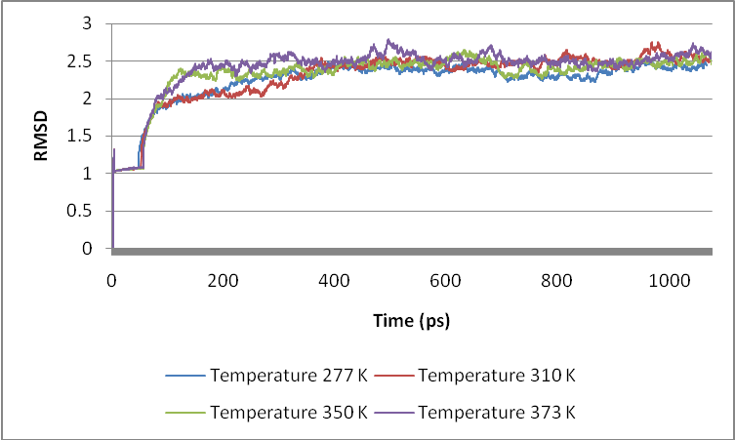

Fig. 2. Graph of RMSD versus time simulated at a various temperatures.

The RMSD values for each temperature showed ​​ that the change in temperature affects the structure of a protein. However, RMSD analysis of Cα atoms only describes the global stability of nimotuzumab F(ab) fragment structure. Therefore, in addition to global stability, the local one is necessary to be studied, especially to the stability of the active regions of a protein. Fig. 3 depicted RMSD analysis for each residue of the heavy chain (see also Fig. 4).

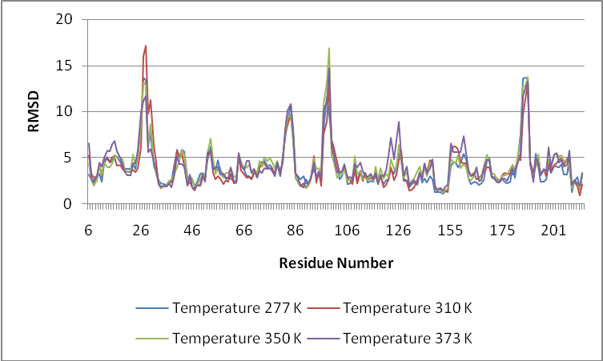

Fig. 3. Graph of RMSD per residue of the heavy chain at a temperature of 277 K , 310 K , 350 K and 373 K.

Increasing the temperature has a considerable effect, especially at residues numbered 27 (tyrosine), 28 (threonine), 83 (arginine), 84 (serine), 98 (tryptophan), 99 (phenylalanine), 183 (threonine), 184 (valine), and 185 (proline), as well.
Table 1 shows that bold numbers are residues numbered 98 (tryptophan) and 99 (phenylalanine) have the highest RMSD value. Both of these residues are in the active region of the CDR3 region of nimotuzumab F(ab) fragment heavy chain. While in the CDR1 and CDR2 regions, conformational changes are lower.

Table 1. RMSD of CDRs at heavy chains
Residue Number | Temperature |  |  |  | Active Regions
Residue Number | 277 K | 310 K | 350 K | 373 K | Active Regions
31 | 4.09826 | 6.35544 | 4.39998 | 4.59832 | CDR1
32 | 3.31039 | 4.48606 | 3.12978 | 3.65685 | CDR1
33 | 2.57676 | 2.13008 | 2.3719 | 2.08144 | CDR1
34 | 2.19873 | 1.68624 | 1.74045 | 1.82967 | CDR1
35 | 2.13463 | 1.96555 | 1.81716 | 1.93581 | CDR1
50 | 3.29149 | 2.79883 | 3.21107 | 3.1205 | CDR2
51 | 2.96262 | 2.66188 | 2.80788 | 2.36553 | CDR2
52 | 4.72147 | 5.35354 | 5.5147 | 5.49044 | CDR2
53 | 6.20754 | 5.55378 | 7.04405 | 5.72595 | CDR2
54 | 4.03009 | 3.35364 | 4.76277 | 3.67969 | CDR2
55 | 3.59234 | 2.6026 | 3.19416 | 3.92815 | CDR2
56 | 4.75153 | 3.01297 | 3.79746 | 4.01523 | CDR2
57 | 3.65281 | 2.74907 | 3.33643 | 3.14433 | CDR2
58 | 3.04487 | 2.14835 | 2.7568 | 3.1875 | CDR2
59 | 2.71378 | 2.51741 | 3.30179 | 2.81572 | CDR2
60 | 2.7341 | 2.4096 | 3.34061 | 2.75258 | CDR2
61 | 2.69814 | 3.26195 | 3.81485 | 3.94231 | CDR2
62 | 2.48246 | 2.20732 | 2.88986 | 2.36917 | CDR2
63 | 2.32883 | 2.25302 | 2.92216 | 2.26935 | CDR2
64 | 5.32329 | 5.19484 | 5.2716 | 5.51224 | CDR2
65 | 4.22324 | 3.64015 | 4.53848 | 4.08544 | CDR2
95 | 3.34142 | 3.53301 | 3.81817 | 3.51976 | CDR3
96 | 2.47042 | 1.91743 | 3.43179 | 2.73598 | CDR3
97 | 8.11146 | 7.56012 | 10.7586 | 10.108 | CDR3
98 | 11.5956 | 8.92937 | 13.1247 | 11.0784 | CDR3
99 | 9.72212 | 12.7386 | 16.8761 | 14.745 | CDR3
100 | 6.87264 | 6.89802 | 5.22259 | 6.07626 | CDR3
101 | 5.67103 | 5.99849 | 4.42606 | 5.08585 | CDR3
102 | 4.46513 | 4.34767 | 2.75966 | 3.42783 | CDR3

Talavera et al. [4], reported that a residue tryptophan H103 plays an important role in nimotuzumab function as a monoclonal antibody. The RMSD values of tryptophan H103 (H refers to heavy chain) during the simulation period at temperatures of 277 K, 310 K, 350 K and 373 K in our study are 2.59, 3.42, 3.01 and 3.30, respectively. This implies that the conformation of H103 will be affected by temperature changes. Analysis of conformational changes was also carried out to the residues of H103, H98 and H99 at temperatures 277 K and 310 K as depicted in Fig. 4. The conformation of the residue H98 at temperatures 277 K was more exposed to solvent than that of 310 K. On the contrary, conformation of the residue H99 was more opened at temperatures of 310 K compared to that of 277 K. The conformation differences of residues of H98 and H99 at a temperature of 277 K and 310 K are very interesting to be considered due to the conjugation process of nimotuzumab F(ab) fragment which is commonly performed at a temperature of 277 K. The probability of the conjugation reaction will be high at the residue H98 because of its smaller steric hindrance and larger solvent accessible surface at 277 K. This will be slightly different at the body temperature of 310 K due to slightly change of H98 conformation that leads to the different effectiveness of nimotuzumab as an anti-EGFR drug.

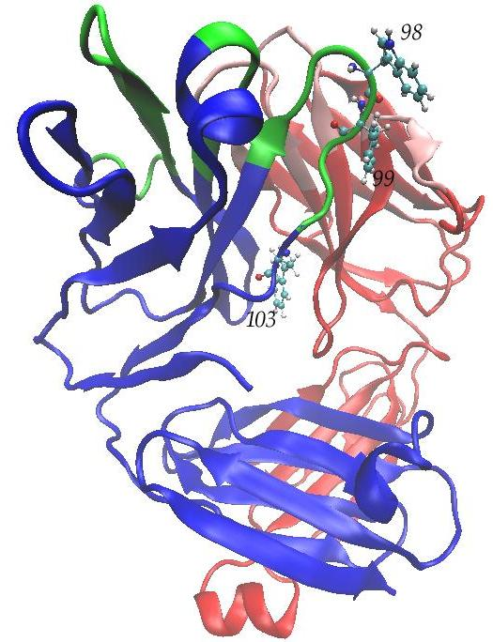 | 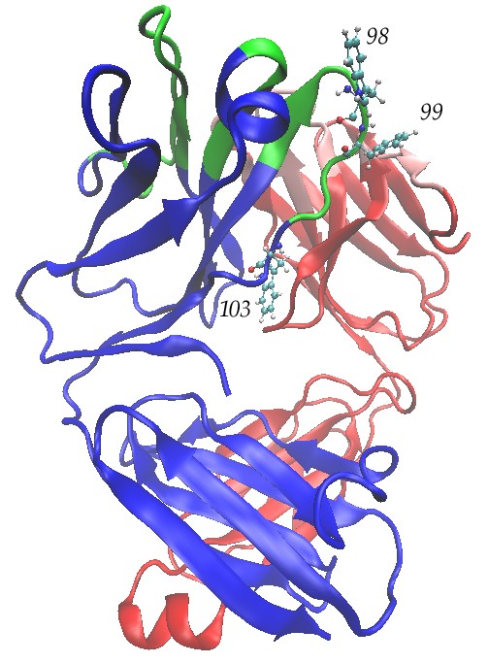
Fig. 4. Three dimensional conformation of residues of H98, H99, and H103 in nimotuzumab structure, left is at temperature 277 K, right is at 310 K.

On the other hand, residue H103 has a higher steric hindrance at temperatures 310 K than that of 277 K due to the interaction between residue H103 and residues of 41-44 from nimotuzumab F(ab) fragment light chain (see Fig. 4). Table 2 shows the effect of each temperature on each residue. The numbers in bold in the Table 2 are the residues that have the highest RMSD value of each peak as shown also in Fig. 3. The grey line represents the residues with the highest RMSD that tend toward a different pattern. It appears that the highest conformational changes at a temperature of 310 K, 350 K and 373 K were identified as residues of 99 and 185. However, at a temperature of 277 K, the highest conformational changes were residues of 98 and 184, one unit less than residues of 99 and 185.

Table 2. Residues of high RMSD at several temperatures

Residue Number | Temperature
Residue Number | 277 K | 310 K | 350 K | 373 K
27 | 13.689 | 16.06 | 13.157 | 11.156
28 | 13.392 | 17.155 | 12.902 | 11.698
83 | 8.9024 | 8.5199 | 9.2354 | 10.116
84 | 10.776 | 9.6806 | 9.6638 | 10.818
98 | 11.596 | 8.9294 | 13.125 | 11.078
99 | 9.7221 | 12.739 | 16.876 | 14.745
183 | 13.623 | 9.6149 | 12.746 | 11.711
184 | 13.664 | 11.379 | 12.736 | 12.601
185 | 13.584 | 12.944 | 13.724 | 13.22

The stability of three dimensional conformation of the active site (CDRs) is necessary to be maintained in order the protein still function normally. Fig. 5 shows RMSD per residue of light chain of nimotuzumab F(ab) fragment at temperatures of 277 K, 310 K, 350 K, and 373 K. It appears that the effect of temperature changes on the light chain of nimotuzumab F(ab) fragment did not result in much change to the structure. However, significant changes occur in the residues numbered 1 (aspartate), 127 (serine), and 186 (tyrosine) as shown in Fig. 5. It can be inferred that all residues in the CDR1 (28-34), CDR2 (50-56), and CDR3 (89-97) have a very small RMSD values (see Fig. 5).

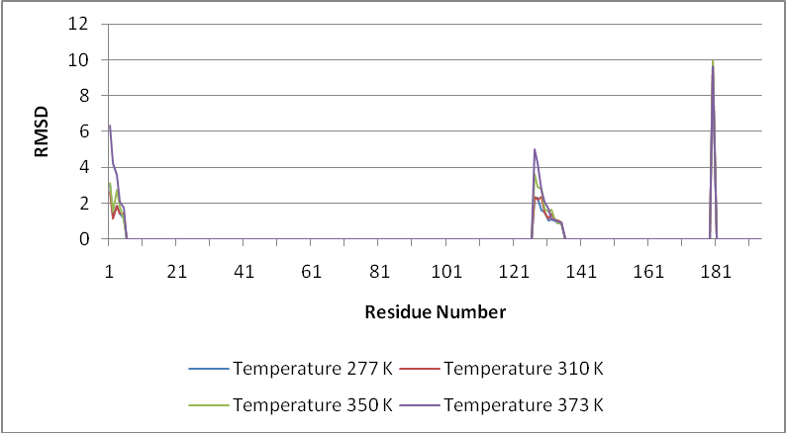

Fig. 5. RMSD per residue of nimotuzumab light chain at temperatures of 277 K, 310 K, 350 K, and 373 K.

In general, RMSD analysis shows that temperature changes will much affect on the conformation of the nimotuzumab F(ab) fragment heavy chain than that of the light chain.

Steered Molecular Dynamics (SMD) Simulations

The purpose of SMD simulations is to determine both the structural stability of nimotuzumab F(ab) fragment that experiences external force and the bonds that affect that stability. SMD simulations were directed to observe the occurrence of unfolding process of each domain in nimotuzumab F(ab) fragment (VL, VH, CL and CH1). First protocol of SMD simulation was performed by pulling nimotuzumab F(ab) fragment with constant velocity of 0.5 Å/ps and 1 Å/ps at the end of the C-terminal of heavy chain, whereas the N-terminal end of the heavy chain was fixed.
The SMD simulation applied for the a heavy chain results in the force peak of 1226 pN for pulling velocity of 0.5 Å/ps and 1688 pN for pulling velocity 1 Å/ps, at 14 ps (Fig. 6). Analysis of hydrogen bonds in this period, indicates that rupture and formation of hydrogen bonds occurs. The total number of hydrogen bonds that occur during the 900 ps simulation is about 699 bonds.

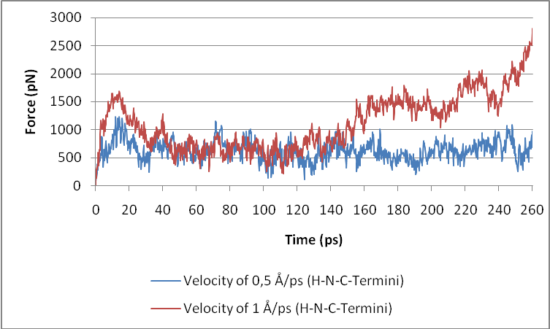

Fig. 6. Graph of force versus time in the first 260 ps SMD simulation. The blue color is a graph obtained at a constant velocity of 0.5 Å/ps, while the red color is a graph obtained at a constant velocity of 1 Å/ps.

At the initial condition, prior the SMD simulation, there were 94 hydrogen bonds present in structure of nimotuzumab F(ab) fragment. Hydrogen bonds exist between residues of the heavy chain and the light chain, inter-residues of heavy chain and light chain. Hydrogen bonds existing between residues of the heavy chain and the light chain play a significant role in the formation of a quaternary structure of nimotuzumab F(ab) fragment, which is the bond that unites the heavy chain polypeptide with a light chain polypeptide. The two chains are linked by seven hydrogen bonds as shown in Table 3.

Table 3. Hydrogen Bonds Between Heavy Chain and Light Chain

No | Donor |  | Acceptor |  | Bond Length (Å)
No | Residue | Atom | Residue | Atom | Bond Length (Å)
1 | SegU-GLN95-Side | HE22 | SegV-TYR36-Side | OH | 1.9
2 | SegU-GLN95-Side | HE21 | SegV-ASP34-Side | OD2 | 1.83
3 | SegV-GLN38-Side | HE21 | SegU-GLN39-Side | OE1 | 1.76
4 | SegU-HSE164-Side | HE2 | SegV-ASP167-Side | OD1 | 1.78
5 | SegV-THR164-Side | HG1 | SegU-HSE164-Side | ND1 | 1.97
6 | SegV-SER162-Side | HG1 | SegU-PRO167-Main | O | 1.77
7 | SegV-GLN160-Side | HE21 | SegU-LEU170-Main | O | 1.91

Description : Seg U is segment U which is the heavy chain, while Seg V is segment V which is the light chain.

For the purpose of simulations, a hydrogen bond is defined if a maximum distance between the donor atom and acceptor atom at 3 Å and the maximum angle formed between these two atoms a is 20°. Fig. 7 (a) shows the relationship between distances of donor and acceptor atoms and simulation time.

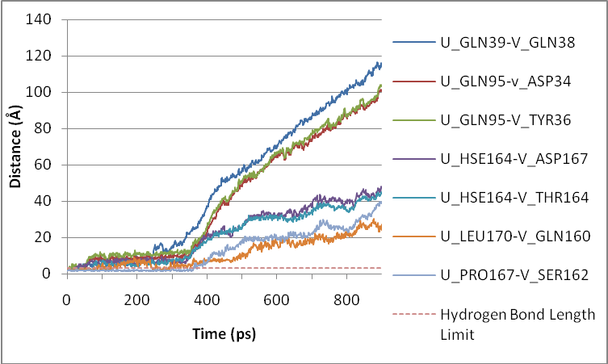
(a)
(b)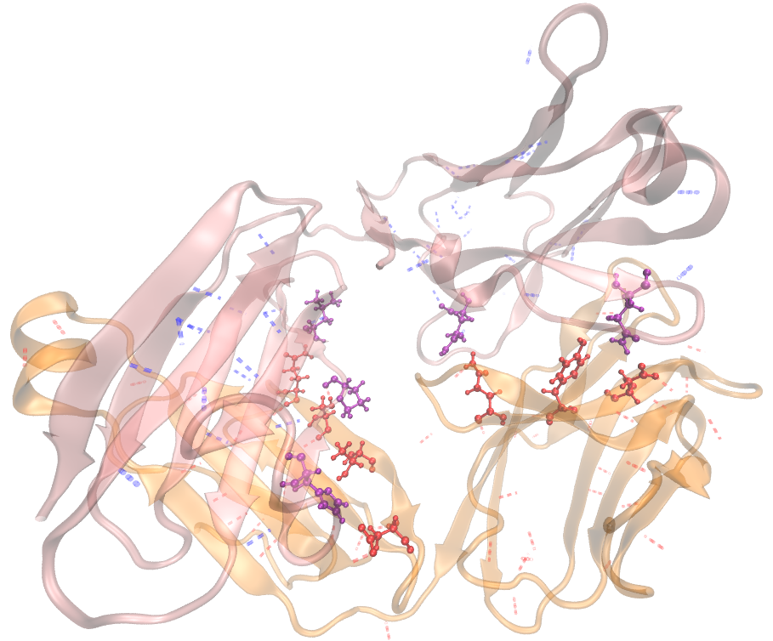

Fig. 7. (a) The distance between donor and acceptor atoms during the simulation period. A fine line is the distance between the two atoms, while the dashed line is the distance of the two atoms that still allows the hydrogen bonds. (b) Rendering of the structure before SMD simulations. Seen the 14 residues forming hydrogen bonds connecting the heavy chain and light chain, with licorice imaging techniques, while the whole structure of nimotuzumab displayed with new cartoon imaging techniques. Figure is created using VMD 1.9 [8].

It appears that the seven hydrogen bonds linking the heavy chain and light chain undergo rupture (distance > 3 Å) at the beginning of the simulation. The bond between residue GLN39 of the heavy chain and residue GLN38 of the light chain would break first at 3 ps simulation, followed by another six hydrogen bonds (Table 4). The breaking of the hydrogen bonds will contribute to the onset of the force peak (Fig. 6) and also can trigger a process of nimotuzumab F(ab) fragment unfolding.
Table 4. The rupture of seven hydrogen bonds between heavy chain and light chain. The first bond breaking occurs from top to bottom

No | Donor  Residue | Acceptor  Residue | Displacement (Å) | Time (ps)
1 | SegV-GLN38-Side | SegU-GLN39-Side | 1.76-3.10 | 3
2 | SegU-HSE164-Side | SegV-ASP167-Side | 1.78-3.76 | 28
3 | SegV-THR164-Side | SegU-HSE164-Side | 1.97-3.09 | 34
4 | SegV-SER162-Side | SegU-PRO167-Main | 1.77-3.12 | 43
5 | SegU-GLN95-Side | SegV-TYR36-Side | 1.9-4.06 | 44
6 | SegU-GLN95-Side | SegV-ASP34-Side | 1.83-3.46 | 50
7 | SegV-GLN160-Side | SegU-LEU170-Main | 1.91-3.43 | 300

Applying force to the C-terminal end of heavy chain, in which this region is close to the CH1 domain of nimotuzumab F(ab) fragment, will be used for analyzing the hydrogen bonds in this domain. From three dimensional structure analysis, the CH1 domain is formed by heavy chain residues numbered 116-212. Accordingly, there are 27 hydrogen bonds in the CH1 domain, in which the bonds between residue LYS143 and ASP144 including between residue GLY162 and THR183 will break up first at 7 ps simulation time. Bond breaking is followed by the bond between residue TYR194 and VAL211 at 14 ps, then the bond between residue GLU148 and TYR145 at 55 ps (see Table 5).

Table 5. The rupture of some of hydrogen bonds between residues of heavy chain. The first bond breaking occurs from top to bottom

No | Donor |  | Acceptor |  | Distance (Å) | Time (ps)
No | Residue | Atom | Residue | Atom | Distance (Å) | Time (ps)
1 | LYS143-Side | HZ2 | ASP144-Side | OD1 | 1,77-3,64 | 7
2 | THR183-Main | HN | GLY162-Main | O | 1,94-3,08 | 7
3 | VAL211-Main | HN | TYR194-Main | O | 1,79-3,13 | 14
4 | TYR145-Side | HH | GLU148-Side | OE1 | 1,67-3,85 | 55

If we compare figure 6 and table 5, there is a correlation between the force peak and the breaking of the hydrogen bonds. At the time of 14 ps simulation with a constant velocity of 0.5 Å/ps, the first force peak is at 1226 pN. At the same time, there is a breaking of the hydrogen bond between the residues VAL211 and TYR194. It can be concluded that the force peak of 1226 pN arises from the rupture of a hydrogen bond between these two residues. It can be presumed that the hydrogen bond between VAL211 and TYR194 residues is one of the bonds determines the stability of CH1 domain. After this peak is reached, the force fall back during the simulation, simultaneously along with the other hydrogen bond breakings. At the end of the simulation, the graph rises sharply until the unfolding process is complete (Fig. 8).

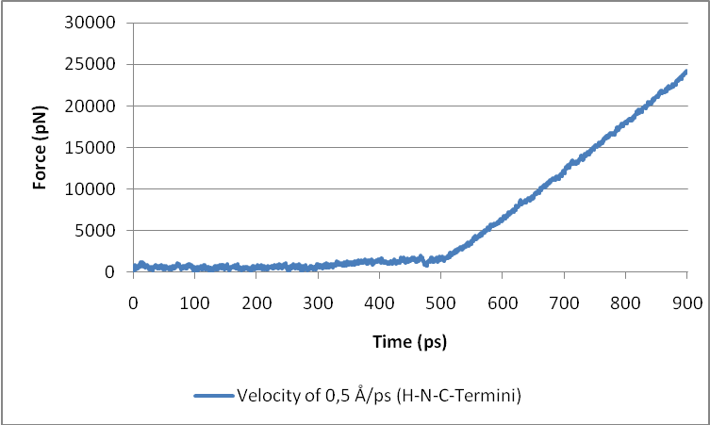

Fig. 8. Graph of force versus time for 900 ps SMD simulation.

Fig.8 shows that after 500 ps of the SMD simulation, the force increases sharply reaching a value of 25.000 pN at 900 ps simulation. This may be due to the quaternary structure of the nimotuzumab F(ab) fragment consisting of two polypeptide chains of heavy and light chains. Due to the force applied to the Cα atoms of the C-terminal end of heavy chain, the force works directly on the heavy chain, rather than on the light chain. Until the end of the simulation, only the heavy chain is undergoing a process of unfolding, whereas the light chain is still in the folded state, thus it results in a huge force which could cause the unfolding process in the light chain (Fig. 9). On the other hand, the results obtained from the SMD simulation with the working force at the Cα atoms of the C-terminal end of light chain, indicate that only light chain is undergoing a process of unfolding, whereas the heavy chain is still in the folded state (Fig. 10). Supposing an analogy to the contrary process, the possibility of the folding process of nimotuzumab F(ab) fragment is initiated with folding on each heavy chains and light chains, which then both chains are joined together to form a quaternary structure of the nimotuzumab F(ab) fragment.

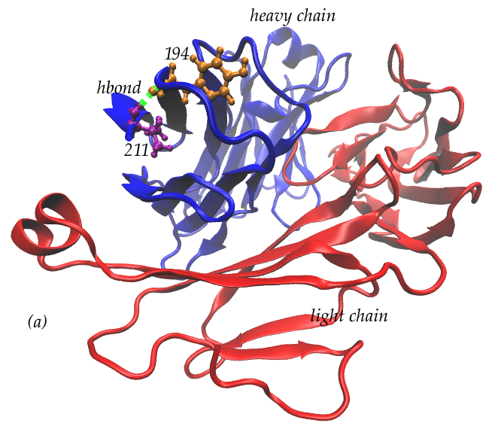 | 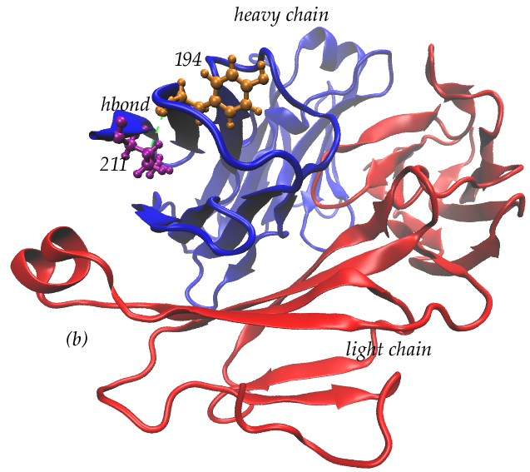 | 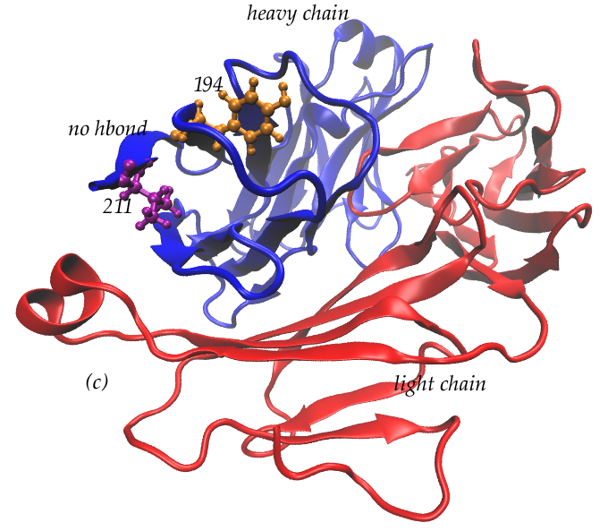
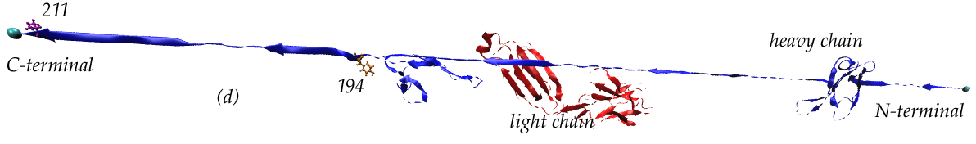

Fig. 9. The process of unfolding and breaking of hydrogen bonds during the SMD simulation with a pulling velocity of 0.5 Å/ps. The blue color is a heavy chain and the red color is a light chain. (a) For 0 ps, there is a hydrogen bond between the TYR194 and VAL21 residues as shown by the green dashed lines, (b) For 7 ps, the hydrogen bond starts to rupture, (c) At 14 ps simulation, there is no presence of hydrogen bond, (d) At 900 ps simulation, the heavy chain has undergone a process of unfolding, whereas the light chain is still in a folded state.

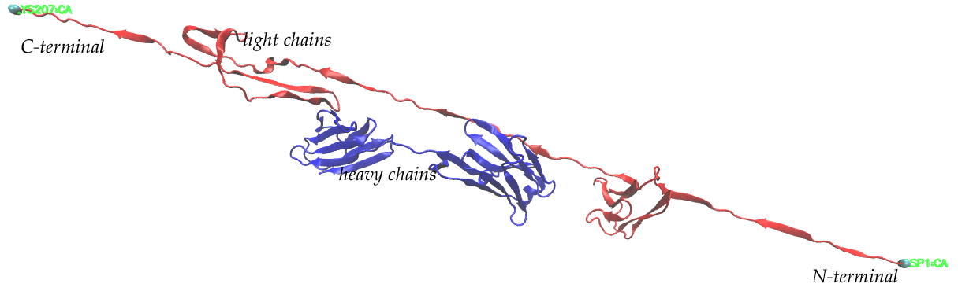

Fig. 10. The results of the SMD simulation doing at a light chain. The blue color is a heavy chain and the red color is a light chain. At 900 ps simulation, the light chain has undergone a process of unfolding, whereas the heavy chain is still in a folded state.

The force peak of 1226 pN in the process of unfolding nimotuzumab F(ab) fragment delineate a protein with a molecular weight of 50 kDa that is relatively small when compared with the actual molecular weight. According to Hui Lu and Klaus Schulten [9], the force needed to pull and lead the unfolding of a protein, depends on the architecture of the proteins.
The protein architecture takes account of three dimensional conformation of secondary structure, the position of β-strand structure (parallel or not parallel), as well as the presence or absence of a hydrogen bonds between the N-terminal and C-terminal, either directly or indirectly. These factors will affect the magnitude of force that is required to trigger protein unfolding process.
There are three classes of proteins according to Hui Lu and Klaus Schulten [9], i.e. class Ia, class Ib and class II. In the structure of class Ia, hydrogen bonds connect directly between the N-terminal and C-terminal, which is laid out in the same direction. It would provide the best protection against the unfolding process because it takes some breaking hydrogen bonds to occur, so it will necessary need a large force. In the structure of class Ib, hydrogen bonds do not connect directly between the N-terminal and C-terminal. The hydrogen bond breakings will occur in a wider place, so it will be a gradual increase in force. Whereas in structure of class II, hydrogen bonds connect directly between the N-terminal and C-terminal, which is laid out in opposite directions. The force required to trigger the process of unfolding is smaller and not enough to cause extreme peak. Hydrogen bonds will rupture one by one so it does not need a great force. Because of the SMD simulations of the nimotuzumab F(ab) fragment were done with work force at the C-terminal end of heavy chain as part of a region of the CH1 domain, whereas the N-terminal end was fixed, the CH1 domain has a architecture-like structure of class Ib as indicated from the results of structural analysis using VMD 1.9 program [8]. In this structure, there are no hydrogen bonds connecting directly between the N-terminal strand and C-terminal strand. However, the hydrogen bonds occurs between the terminal strand and non-terminal strand. The position of the N-terminal and C-terminal of CH1 domain is also located in the opposite direction (see Fig. 11).

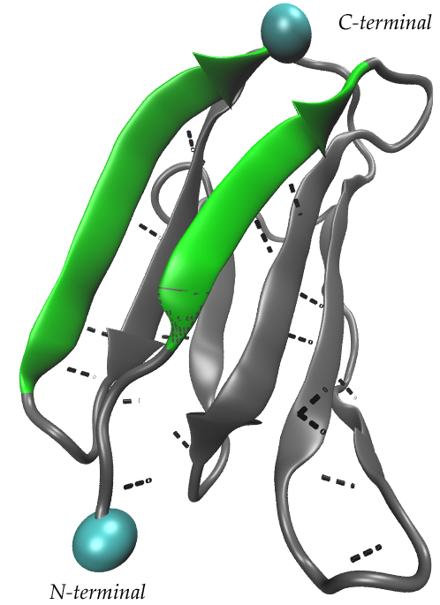

Fig. 11. Architecture of the CH1 domain resembles classes Ib made by Hui Lu and Klaus Schulten [9]. The green color depicts the N-terminal and C-terminal strands. This figure is created using VMD 1.9 [8].

In addition to SMD simulations performed at a constant velocity of 0.5 Å/ps, simulations were also carried out with the pulling velocity of 1 Å/ps and resulted in force peak of 1688 pN at 14 ps. This force is greater than that of a velocity of 0.5 Å/ps. Therefore, the force required to cause the unfolding process of nimotuzumab F(ab) fragment using atomic force microscopy (AFM), is predicted to be smaller, because of the pulling velocity used by SMD simulations is larger than the AFM. In SMD simulation with a pulling velocity of 0.5 Å/ps, force peak of 1226 pN can be obtained. In addition, SMD simulations at a constant velocity of 0.5 Å/ps, the rupture of the hydrogen bond between the residue TYR194 and residue VAL211 occur after 14 ps simulation or after 7 Å lengthening.
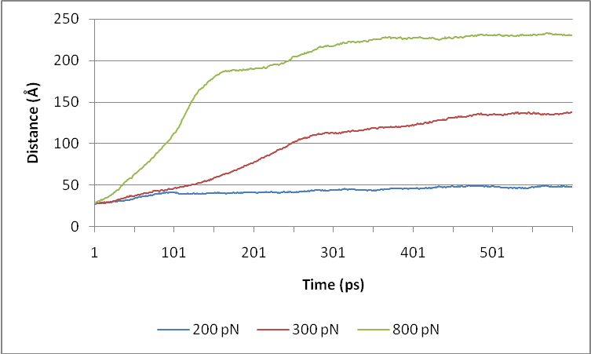

Fig. 12. Graph of N-terminal and C-terminal distance versus time

Further the SMD simulation using second protocol with contstant force, the rupture of the hydrogen bond between these two residues, TYR194 and VAL211, will occur at 484 ps, 29 ps and 1 ps for the work forces of 200 pN, 300 pN and 800 pN, respectively (Fig. 12). It can be concluded that in the actual experiment (AFM), the force required to trigger the unfolding process of CH1 domain of the heavy chain nimotuzumab F(ab) fragment ranges from 300 pN to 800 pN.

conclusion

We have performed molecular dynamics simulation of nimotuzumab F(ab) fragment in various temperatures and steered molecular dynamics (SMD) simulation at a constant velocity of 0.5 Å/ps. It can be concluded that temperature changes have a considerable effect to conformation of both heavy and light chains of nimotuzumab F(ab) fragment, especially at residues numbered 27 (tyrosine), 28 (threonine), 83 (arginine), 84 (serine), 98 (tryptophan), 99 (phenylalanine), 183 (threonine), 184 (valine), and 185 (proline) for heavy chain and 1 (aspartate), 127 (serine), and 186 (tyrosine) for light chain, respectively. The residues numbered 98 and 99 are part of CDR3, however, the conformational changes of residues in the CDR1 and CDR2 regions are much lower. Based on the SMD simulations, the hydrogen bond between residue VAL211 and TYR194 determines the stability of CH1 domain of the nimotuzumab F(ab) fragment.
For further research, it is advisable to perform molecular dynamics simulations of immunoconjugates of radiolabeled nimotuzumab and their interactions with EGFR in blood plasma at body temperature.

ACKNOWLEDGMENT

The author would like to thank Hasan Al - Rashid for any advice and assistance during the research, and the Centre for Education and Training-National Nuclear Energy Agency of Indonesia (BATAN) which has provided financial assistance for this study. The authors also like to thank all those who have given advice, motivation and support both materially and spiritually, so that this research can be completed.

references

1. M. Takeda, I. Okamoto, Y. Nishimura et al., Lung Cancer : Target and Therapy 2 (2011) 59.
2. M.O. Rodriguez, T.C. Rivero, B.R. del Castillo et al., Cancer Biology and Therapy 9 (2009) 343.
3. A.M. Scott, J.P. Allison, and J.D. Wolchok, Cancer Immunity 12 (2012) 14.
4. A. Talavera, R. Friemann, S.G. Puerta et al., Cancer Res 69 (2009) 5851.
5. D.G.P. Allan, The Oncologist 10 (2005) 760.
6. T.S. Humani, M. Ramli, C.T. Rustendi et al., Preparation and Stability Test of ¹⁷⁷Lu-DOTA-Nimotuzumab as a Radioimmunotherapy of Cancer, Proceedings of National Seminar on Human Resources of Nuclear Technology VI (2010) 663.
7. J.C. Phillips, R. Braun, W. Wang et al., Journal of Computational Chemistry 26 (2005) 1781.
8. W. Humphrey, A. Dalke, and K. Schulten, Journal of Molecular Graphics 14 (1996) 33.
9. H. Lu, and K. Schulten, PROTEINS: Structure, Function and Genetics 35 (1999) 453.

 Corresponding author. E-mail address: humani@batan.go.id

