Safety Investigation of Hazardous Materials Release from The Combined High Temperature Gas Cooled Reactor – Hydrogen Production Plant
Atom Indonesia

D. Priambodo^{1*}, Sunarko¹, W. Wahyu Purwanto²
¹ Centre for Nuclear Energy System-National Nuclear Energy Agency (PKSEN_BATAN), Jl. Kuningan Barat, Mampang Prapatan Jakarta, 12710, Indonesia
² Sustainable Energy Systems and Policy Research Cluster, Department of Chemical Engineering, University of Indonesia, Kampus UI Depok, 16424, Indonesia

A R T I C L E I N F O a B S T R A C T

AIJ use only:  Received date  Revised date  Accepted date  Keywords:  Hydrogen  ALOHA  Hazardous material  Toxication  Flammable  Blast  Dispersion |  | The objective of this study was to investigate the presence of natural gas, synthetic gas from Steam Methane Reforming (SMR) hydrogen plant on the combine HTGR-Hydrogen production system to predict the outcome of such accidents using ALOHA software. Three selected hazardous materials, CH₄, CO and H₂ were analyzed. The selected potential hazards of hazardous materials after leaking from the pipe were downwind suffocation/toxication, flammable area and blast area from vapor cloud explosion. Two types of parameter, meteorological dispersion (includes wind speed, temperature, humidity, nuclear building air changes for day and night) and source release parameters (includes pipeline length, and distance reactor building to hydrogen plant) were selected for this study. Then the effects of the parameters on the hazard distance were analyzed. The study has shown that atmospheric stability and a low wind speed lead the longest affected distance for toxication, flammable and blast area of hazardous material. The downwind toxication of CO could threathen the reactor building operators’ life for all parameter conditions. The flammable vapor cloud and overpressure wave from H₂ be threating the reactor building properties and operator’s life.  © 2010 Atom Indonesia. All rights reserved

Introduction∗

Currently all of the urea plants in Indonesia using natural gas both as a feedstock and fuel in the Steam Methane Reforming (SMR) process for their hydrogen production. Some of the plants have begun switching to coal to generate power and steam due to the limitation of natural gas supply. However, the provision of chemical reactor process heat still uses natural gas. Although natural gas is the cleanest and the most convenient feedstock among the hydrocarbon fuels to produce urea, natural gas is the world’s fastest growing fossil fuel, with consumption increasing from 3,000 Mtoe in 2015 to 4,250 MTOE in 2040 [1]. In addition, based on Indonesian natural gas balance 2012-2025, Indonesia is facing declining natural gas production from many older fields and must make substantial investment to maintain current production levels. Therefore nuclear is expected to become a major process heat source for hydrogen production by applying the SMR process in the future with the necessary modification of chemical reactor design [2][3].
The High Temperature Gas-cooled Reactor (HTGR) is an advanced-generation reactor capable of utilizing high temperature coolant of up to 950°C, which is significantly higher than the ~325°C coolant exit temperature that can be used with light water reactors (LWRs). The HTGR can be used for high efficiency power production with both a gas-turbine in a direct cycle and/or a superheated steam turbine, as a process heat supply using high temperature helium or steam for a hydrogen production plant or other chemical plants [4–10].
To realize the utilization of nuclear energy, especially HTGR, as a process heat source, the safety design for an integrated HTGR-hydrogen plant should be analyzed. Several studies have been conducted on the safety aspects of nuclear hydrogen systems. US-NRC performed the identification of phenomena relevant to the safety of a nuclear facility when coupled to a hydrogen production plant. A ranking table with criteria for accident phenomena in the coupled system has been established [11]. In addition, possible accident scenarios of the system HTGR plus hydrogen plant based on the sulfur-iodine (S-I) process have been proposed and investigated through qualitative reasoning by Brown et al. [12,13]. Kai Wang investigated the effect of a high pressure hydrogen leak model with multi-parameters to the distribution of hydrogent flammable area [14]. Zhaolin Wang et al. examined the heat and chemical hazard for the integration of nuclear reactors and thermochemical hydrogen plants [15]. Verfondern et al. examined the release, dispersive transport, and explosion of a hydrogen cloud in the atmosphere as well as the release of toxic substances from the JAEA design of an HTGR-S-I hydrogen production plant and their transport towards the NPP control room [16]. Sato et.al suggested safety requirements and design considerations of such a system [17]. On the other hand, Verfondern and Nishihara investigated particular safety aspects for a combined HTTR-SMR complex such as fire and explosion hazards at the liquid natural gas storage tank, hydrogen storage tank and CO near the HTTR building by using JAERI (today: JAEA) computer tools [18]. Alimah and Sriyono conducted an assessment on the safety distance between nuclear installation and hydrogen storage tank. They have applied the German BMI’s empirical formula to determine the minimum separation distance to the hydrogent storage [19].
From the literatures above, it is known that most focus was on studying the potential hazards arising from the storage systems of either hydrogen or LNG, representing the highest risk to the HTGR because of their huge energy contents. The objective of this study was to investigate the atmospheric dispersion behavior of natural gas or synthesis gas from an SMR-based hydrogen plant combined with an HTGR to predict the consequences of such inadvertent release accident scenarios. The so-called Areal Locations of Hazardous Atmospheres (ALOHA) code was utilized to predict the outcome of a hazardous material release from a pipeline carrying natural gas as feed for the reformer, and hydrogen, CO, and CO₂, respectively, as product gases from the reforming process, which are categorized as hazardous materials. Using ALOHA, probable impacts of the evolving flammable and/or toxic gas clouds, thermal radiation zones and overpressure waves can be assessed. In the following section, the methodology of the research is introduced, then assumed scenarios are introduced and finally the results are shown. The paper concludes with a discussion of the results, suggestions and conclusions.
Fig. 1. HTGR-SMR system for nuclear-assisted hydrogen production

THEORY
Combined HTGR-hydrogen production system based on Steam-Methane Reforming
Author, in the previous study, describe the SMR hydrogen production as a process consisting of three stages: steam reforming, shift reaction, and hydrogen product purification as shown in Fig. 1 [2]. The steam reforming process involves methane reacting with medium pressure steam at 750-800°C to produce synthesis gas (syngas), a mixture primarily composed of hydrogen (H₂), carbon dioxide (CO₂) and carbon monoxide (CO). The steam reforming reaction is endothermic, i.e. heat must be supplied to the process for the reaction to proceed. The process heat required in the primary reformer (PR) is supplied by helium gas from the HTGR via an intermediate heat exchanger (IHX) to the secondary helium circuit. The specification of the PR and its catalyst have been studied by the authors in the previous study [2]. In addition, the system will be equipped with a secondary reformer (SR). Process gas from the PR is reacted with oxygen in the SR to produce a syngas mixture that is ideal for methanol synthesis or with air to produce ideal syngas for ammonia. The SR is much more compact than the PR. In the SR, combustion of the process gas hydrocarbon in oxygen causes a temperature rise that provides heat for the secondary reforming reaction. The SR will reduce the remaining methane from PR then increase the share of CO & CO₂ in the syngas. In the second step, known as the water gas shift (WGS) reaction, the CO produced in the ﬁrst reaction is reacted with steam over a catalyst to form hydrogen and CO₂. This process occurs in two stages, consisting of a high temperature shift (HTS) at 350-400ºC and a low temperature shift (LTS) at 190-250ºC. The last stage is a purification that serves to separate the main products H₂ and CO₂. The modern plant for purification will apply Pressure Swing Adsorber (PSA) for separating H₂ from the syngas that can meet purity requirements up to 99.999 mole % of H₂ [20,21].
As described in the previous study [2], the HTGR-SMR plant considered here is designed to produce 150,000 tonnes/year or 5.3 kg/s of hydrogen. Correspondingly the need of natural gas feed to the PR is 15.9 kg/s (66.4% CH₄) and 51.6 kg/s of Medium Pressure Steam. The heat of the endothermic reaction is 513 MJ/h ≈ 143 MW_{th} which is to be supplied by the HTGR. In the SR, syngas is reacted with 7.9 kg/s of oxygen. During operation, 75.5 kg/s of syngas is formed that is made up of CH₄, H₂, CO, CO₂, H₂O and N₂. A detailed composition of the gas mixture at various positions in the SMR plant is described in Table 1.

Table 1. Syngas composition
Location | Composition | %
Outlet PR | CH₄  CO  CO₂  H₂O  H₂  N₂ | 8.05  10.48  21.68  54.51  5.25  0.03
Outlet SR | CH₄  CO  CO₂  H₂O  H₂  N₂ | 0.54  20.51  20.14  52.89  5.90  0.02
Outlet HTS | CH₄  CO  CO₂  H₂O  H₂  N₂ | 0.54  4.83  44.78  42.80  7.03  0.02
Outlet LTS | CH₄  CO  CO₂  H₂O  H₂  N₂ | 0.54  0.51  51.57  40.02  7.34  0.02
Purge PSA  side-product | CH₄  CO  CO₂  H₂O  H₂  N₂ | 0.54  0.51  51.57  0.23  0.37  0.02

Method
The Areal Locations of Hazardous Atmospheres (ALOHA) code
The accident scenarios were calculated using ALOHA which was developed by the United States Environmental Protection Agency (U.S. EPA) and the National Oceanic and Atmospheric Administration (NOAA) [22]. The mathematical models used in ALOHA are: Gaussian model, heavy gas dispersion model, vapor cloud explosion model, and BLEVE fireball model. The calculation steps of the outcome of hazardous material release from a gas pipeline within the combined HTGR-Hydrogen production system using ALOHA is shown in Fig. 2 [23].

Hazardous material identification
The hazardous materials have been identified by using rating systems for health (Nh), flammability (Nf) and reactivity (Nr) from the National Fire Protection Association (NFPA) system and the material factors (MF) [24–26], as shown in Table 2
Table 2. Material safety data sheet
No | Material | Nh | Nf | Nr | MF
1 | He | 0 | 0 | 0 | 1
2 | CH₄ | 2 | 4 | 0 | 21
3 | CO | 3 | 4 | 0 | 21
4 | CO₂ | 2 | 0 | 0 | 1
5 | H₂ | 0 | 4 | 0 | 21
6 | H₂O | 0 | 0 | 0 | 1
7 | N₂ | 0 | 0 | 0 | 1

From the Table 2, the chemicals in lines 1, 4, 6 and 7 are not representing hazardous materials and no longer considered in this study. Through combination of flowrate and material factor, the hazardous chemicals can be sorted to 15.9 kg/s of natural gas (feedstock assumed to be 100% methane) at inlet PR, 15.4 kg/s CO at outlet SR and 5.3 kg/s of H₂ (product) at the PSA unit.

Accident scenarios
To study the accident consequences, release scenarios were developed and calculated. In this study, the model parameters are divided into source release and atmospheric dispersion parameters. The meteorological dispersion parameters include wind speed, temperature, hu midity, nuclear building air changes for day and night; the source release parameters include pipeline length, and distance from reactor building to hydrogen plant. While pressures and temperatures of the fluid will be taken from the author’s previous study, Fig. 1 [2], the pipe diameter will be derived by trial and error to find the designed flowrate of material.

Table 3. Meteorology
 | Wind speed (m/s) | Temperature  (°C) | Humidity (%) | Cloud cover
Day | 2; 2.5; 3; 3.5; 4 | 32 | 70 | Partly
Night | 6; 6.5; 7; 7.5; 8 | 26 | 85 | Partly
Fig. 2. Calculation steps in ALOHA
The pipe length assumed to be 1 km is only applicable to natural gas, which is to be transferred from the natural gas reservoir compressor to the hydrogen production plant. For the other materials investigated, a 200 meter pipe length was assumed as these gases are transferred between components inside the plant. Air change in the reactor building was assumed as 2 per hour and the separation distance between reactor building and hydrogen plant is 200 m. In the calculation of the impact from the overpressure wave, the worst-case scenario resulting in a detonation was selected. In addition, the worst-case scenario assumes the wind to blow from the hydrogen plant in the direction of the nuclear plant, the pipeline was totally ruptured and with regard to topography, open country was assumed, i.e. no obstacle to gas dispersion present.

results and discussion

The potential hazards of a hazardous material after leaking from the pipe are downwind suffocation/intoxication and vapor cloud explosion of regions within the flammability limits when ignited after escaping from pipeline, connected with blast overpressures within a certain area.
Affected distance analysis
For toxic release accidents, the study uses public exposure guidelines preferentially for the toxic levels of concern (LOC), because these guidelines are specifically designed to predict how the general public will respond to a short-term, one- time release. The most common public exposure guidelines have three tiers of exposure values for each covered chemical.
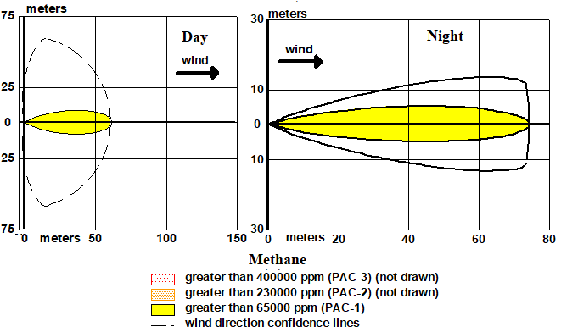
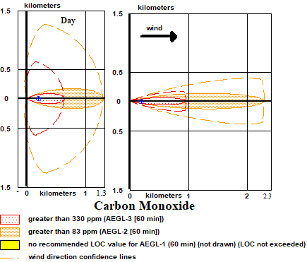
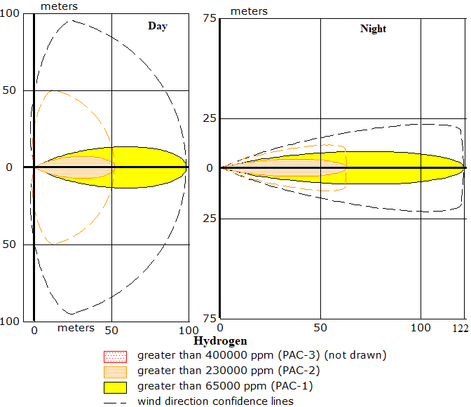
Fig. 3. Threat zone of intoxication for CH4, CO, and H2 at wind speed: 2ms⁻¹ for day and 6 ms⁻¹ for night
The first tier or yellow zone is a mild effects threshold, the second tier or orange zone is an escape-impairment threshold, and the third tier or red zone is a life-threatening effects threshold [22]. With regard to CO, the Acute Exposure Guideline Levels (AEGLs) for zoning the threat of a toxic material are used; for the other hazardous materials CH₄ and H₂, the Protective Action Criteria for Chemicals (PACs) are employed, as there are no AEGL values in the ALOHA library for those materials. The AEGL values for CO were defined as AEGL-3 (red zone-330 ppm 60 min) and AEGL-2 (orange zone-83 ppm 60 min).
The flammability range of a gas-air mixture is the concentration percentage between the two values of lower explosive limit (LEL) and upper explosive limit (UEL). For the purpose of conservativism, ALOHA uses 60% and 10% of LEL as the lower flammability limit of the vapor cloud. If a flammable region of the vapour cloud comes into contact with an ignition source, it will burn fast and forms an overpressure wave.
In this study, the default overpressure wave zone from ALOHA was used which is defined as follows: 8.0 psi (red zone-destruction of building), 3.5 psi (orange zone-serious injury) and 1.0 psi (yellow zone-shatters glass). However, this study considers only the red and orange zones. Since the maximum design pressure of the HTGR containment building has not been designed yet, the design pressure selected here was 180 psi [27].
Fig. 3 presents the shape of the toxic threat zones of H₂, CH₄ and CO under two conditions: at day wind speed of 2 m/s, atmosphere temperature of 32°C, humidity of 70%; and at night 6 m/s, 26°C, 85%, and partly cloudy for both conditions. The effects of the wind speed parameters at day and night are shown in Fig. 4. A higher wind speed results in shorter toxic affected distances for both day or night condition. The results for day and night exhibit significant differences for all hazardous materials. The influence of wind speed and day/night conditions on the affected distance could be explained as follows: the wind causes the hazardous gas cloud to disperse in downwind direction, while the gas concentration in the vapor cloud is continuously decreasing. This results in a shortening of both the toxic and the flammable vapor cloud extension.
The atmospheric conditions for dispersion parameters for day time are classified in Pasquill’s atmospheric stability categories of A (highly unstable), B (moderately unstable) and C (slightly unstable) whereas night time has the categories D (neutral), E (slightly stable) and F (moderately stable) [28].
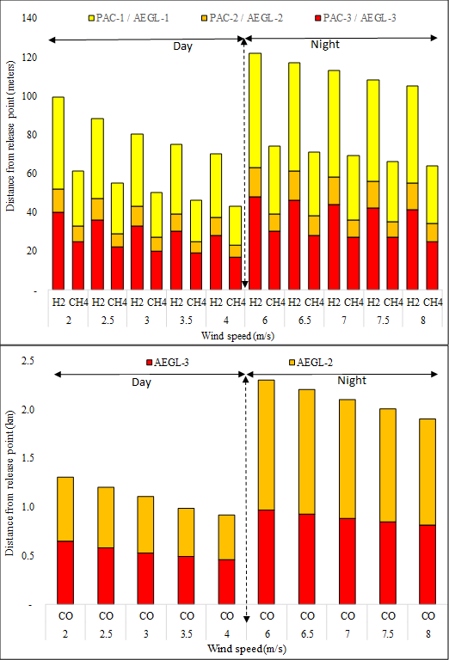
Fig. 4 Affected distance of toxic threat by the hazardous materials H₂, CH₄ and CO
For the dispersion parameters at day time, the hazardous gas cloud diluted faster due to the higher atmospheric turbulence level, hence, the impacted zones did not expand much in the surrounding areas. However, during the night which corresponds to the atmospheric classes of D, E and F, the affected distance expanded faster away from the release location. The analysis of the shape of the threat zone and affected distance in relation to the atmospheric stability class shows that, as the conditions change from unstable to stable atmospheric conditions, the affected distance becomes narrower and more extended in wind direction (see Fig. 3, Fig. 4, Fig. 5).

Fig. 5. Affected distance of (a) flammable vapor cloud (b) overpressure wave
Fig. 4 presents the affected distances where CO has the longest distance followed by H_{2,} while CH₄ has the shortest distance under all conditions assumed. This behavior of CO is due to the fact that it has one of the highest flowrates, a high release rate from the system (CH₄ is the highest), and it has the smallest LOC value, 330 ppm for red zone compared with 400,000 ppm for H₂ and CH₄ red zones. Furthermore, H₂ has a longer affected distance than CH_{4,} even though they have the same LOC values. This phenomenon is due to the effect of H₂ density, which is lower than that of CH₄, 0.0899 kg/m³ of H₂ compared to 0.717 kg/m³ of CH₄. The less dense material will spread more quickly at higher wind speeds.
Fig. 5 presents the estimation of affected distances of the flammable vapor cloud and overpressure wave. The trend of both flammable vapor cloud and overpressure wave is similar. Once the flammable vapor cloud reaches an ignition source, this part of the cloud could burn. In some cases, the chemical substance will burn very fast to cause a strong explosion. The strength of the explosion is a function of material, cloud size, type of ignition, and congestion level inside the vapor cloud. The affected distances for H₂, CH₄ and CO on the flammable vapor cloud and overpressure wave show the same trend with H₂ having the longest, followed by CH₄ and CO. These phenomena are due to the large difference in the values of LEL and UEL of H₂ (LEL: 4 % and UEL: 75 %), then CH₄ (LEL: 5 % and UEL: 15 %) and finally CO (LEL: 12.5 % and UEL: 74.2 %).

Safety distance analysis for the Nuclear-Hydrogen Plant
From the safety distance point of view, the CO, for both day and night conditions, was the only toxication material which could threaten to reach the reactor building. From the assumption of 2 per hour of air change inside the reactor building, the toxic effect of CO that reaches the internal reactor building is a concentration far above 330 ppm or AEGL-3 toxic level (life-threatening health effects to employee/operator). The lowest concentration is 1,700 ppm at day time with a wind speed of 4.0 m/s and the highest concentration is 5,430 ppm at night time with a wind speed of 6.0 m/s.
The case of flammable vapor cloud shows that H₂ is the only hazardous material that disperses to the reactor building. There are two conditions at day time and all conditions at night time which resulted in 60% LEL (24,000 ppm) inside the reactor building. The concentrations are 31,300 ppm and 25,100 ppm at day time with wind speeds of 2.0 m/s and 2.5 m/s, respectively, while at the night time the highest concentration is 50,000 ppm with a wind speed of 6.0 m/s and the lowest concentration is 37,500 ppm with a wind speed of 8.0 m/s. Thus, on those conditions, the inside of the reactor building is very prone to a fire accident if there were a leak of hydrogen product from the hydrogen plant.
As with fire, the explosion threat is also caused only by H₂. The highest overpressure wave received by the reactor building is 292 psi, occurring at night time when wind speeds are 6 – 7 m/s. Compared with selected containment design pressures, the destructive explosion power of H₂ vapor cloud could damage the reactor building. That pressure force not only threatens the reactor building itself but also the operators' life. Under all conditions at day and night time, the overpressure wave from the explosion of the H₂-air cloud could seriously injure employees/operators around the reactor building. According to Fig. 5b) the maximum destruction distance that could be encompassed by the overpressure wave from the H₂ explosion is 250 meter.

conclusion

The study has shown that the affected distances were significantly dependent on the atmospheric stability. Atmospheric dispersion of the hazardous materials happened to be faster at day time (unstable condition) than at night time due to the ability of the air to better dilute the gas cloud by dispersion at night in comparison to day time when turbulence is lower (stable condition). In addition, the wind speed had a considerable influence on the dispersion of the hazardous material and the extension of the affected distance, since the wind blows the hazardous gas cloud to disperse in wind direction, and the concentration of the vapor cloud is diluted continuously, resulting in a shortening of both the toxic and the flammable vapor cloud distance. The study also showed that the flowrates of the gases and their values of LOC and LEL have a strong effect on the affected distances. From the safety distance point of view, the separation distance between reactor building and hydrogen plant was 200 meter. Under all conditions, CO was the only toxic material which could reach the reactor building and give life-threatening health effects to employees/operators. H₂ was the gas that could be threating the reactor building properties and operators’ life due to the estimated affected distance of its flammable vapor cloud and overpressure wave. The flammable H₂–air vapor cloud could reach the reactor building at day time with wind speeds of 2.0 m/s and 2.5 and at night time with all wind speeds selected. The overpressure force of 292 psi from the H₂ explosion could destroy the reactor building and threaten the operators’ life at night time with wind speeds of 6 – 7 m/s. Moreover, from all conditions at day and night time, the overpressure wave from the explosion of the H₂-air cloud could seriously injure employees/operators around the reactor building. For protecting operators from CO poisoning, CO adsorber equipment could be installed in the heating, ventilation, and air conditioning (HVAC) system of the reactor building so that the CO concentration in the reactor building could be sufficiently reduced or eliminated during an CO release accident. The same method could be adopted to reduce H₂ flammable gas concentration during a H₂ leakage accident by installing H₂ recombiner/adsorber in the HVAC system. Provision of a separation distance of more than 250 meter between the HTGR and the hydrogen production system is a simple and reliable safety approach to protect the reactor building from the overpressure wave following a H₂ explosion. Another method is to construct a blast barrier between reactor building and hydrogen plant to divert the gas cloud and, in case of an explosion, reduce the pressure force reaching the reactor building.

ACKNOWLEDGMENT

We thank Dr. Karl Verfonder for assistance comments that greatly improved the manuscript.

references

[1] IEA, World Energy Outlook 2016, 2016.
[2] D. Priambodo, E. Dewita, S. Ariyanto, J. Pengemb. Energi Nukl. Vol. 14 No (2012) 95–106.
[3] V.Klimova, V.Pakhaluev, S.Shcheklein, Int. J. Hydrogen Energy 41 (2016) 3320–3325.
[4] K. Verfondern, WernerVon Lensa, Prog. Nucl. Energy 47 (2005) 472–483.
[5] X.Yan, H.Noguchi, H.Sato, et al., Nucl. Eng. Des. 271 (2014) 20–29.
[6] C.H. Shin D, Kim C, Park G, Int. J. Hydrogen Energy 42 (2017) 22046–22053.
[7] M. Al-Zareer, I. Dincer, M.A. Rosen, Energy Convers. Manag. 205 (2020) 112387.
[8] R. Pinsky, P. Sabharwall, J. Hartvigsen, et al., Prog. Nucl. Energy 123 (2020) 103317.
[9] H. Sato, T. Aoki, H. Ohashi, et al., Nucl. Eng. Des. 360 (2020) 110493.
[10] A. Odukoya, G.F. Naterer, M. Roeb, et al., Int. J. Hydrogen Energy (2016).
[11] US NRC, Next Generation Nuclear Plant Phenomena Identification and Ranking Tables (PIRTs) Volume 6: Process Heat and Hydrogen Co-Generation PIRTs, Oak Ridge National Laboratory P.O. Box 2008 Oak Ridge, TN 37831-6170, 2008.
[12] N.R. Brown, V. Seker, S.T. Revankar, et al., in: Nucl. Eng. Des., 2012, pp. 256–265.
[13] N.R. Brown, S.T. Revankar, in: Nucl. Eng. Des., 2012, pp. 266–276.
[14] K. Wang, X. Zhang, Y. Miao, et al., Int. J. Hydrogen Energy (2020).
[15] Z. Wang, E. Secnik, G.F. Naterer, Process Saf. Environ. Prot. (2015).
[16] K. Verfondern, X. Yan, T. Nishihara, et al., Int. J. Hydrogen Energy 42 (2017) 7551–7559.
[17] H. Sato, H. Ohashi, S. Nakagawa, et al., Prog. Nucl. Energy 82 (2015) 46–52.
[18] K. Verfondern, T. Nishihara, Prog. Nucl. Energy 47 (2005) 527–534.
[19] S. S. Alimah, J. Pengemb. Energi Nukl. Vol. 15 (2013) 36–45.
[20] E. Herianto, W.R. Wan Daud, S. E.Iyuke, et al., Int. J. Hydrogen Energy 34 (2009) 2771–2777.
[21] M.R.Rahimpour, M.Ghaemi, S.M.Jokar, et al., Chem. Eng. J. 226 (2013) 444–459.
[22] United States Environmental Protection Agency, National Oceanic and Atmospheric Administration, (2007).
[23] Yafei Zhou, Guangyu Hu, Jianfeng Li, Chunyan Diao, Land Use Policy 38 (2014) 233–238.
[24] National Fire Protection Association, NFPA 704: Standard System for the Identification of the Hazards of Materials for Emergency Response, 2012.
[25] NOAA, US EPA, (n.d.).
[26] S. Mannan, Lees’ Loss Prevention in the Process Industries, Volumes 1-3 - Hazard Identification, Assessment and Control (4th Edition), 4th ed., Elsevier Inc., 2012.
[27] J.D. Stevenson, in: Struct. Mech. React. Technol. SMiRT 19, IASMiRT, Toronto, Canada, 2007, pp. 1–8.
[28] S. Comarova, Z., Mangul, in: Barnes I., Kharytonov M.M. (Eds.), Simul. Assess. Chem. Process. a Multiph. Environ. NATO Sci. Peace Secur. Ser. C Environ. Secur., Springer, Dordrecht, 2008, pp. 403–408.

If you find difficulties in placing figures or table in the text above, please insert them in this page!

∗ Corresponding author. E-mail address: dedypriambodo@batan.go.id

